www.mathsrevision.com
Advanced Higher Maths
Advanced Higher - Unit 3.3 Complex Number Theory - Solutions

Mr. Lafferty BSC (Hons) Open MathSci & Mrs Bissett BSC (Hons) Glasgow

Ex 4 Expressing z = r[cosθ + isinθ]

- $\left(a\right)(i) z_{1}=2\left(cos\frac{π}{4}+isin\frac{π}{4}\right) ; r=\left|z_{1}\right|=2 and θ=arg⁡(z_{1})=\frac{π}{4}$

$$(ii) z_{2}=3\left(cos\frac{π}{4}+isin\frac{π}{4}\right) ; r=\left|z_{2}\right|=3 and θ=arg⁡(z_{2})=\frac{π}{4}$$

$${ \left(iii\right) z}_{1}z_{2}=2\left(cos\frac{π}{4}+isin\frac{π}{4}\right)×3\left(cos\frac{π}{4}+isin\frac{π}{4}\right)=6\left(cos\frac{π}{4}+isin\frac{π}{4}\right)\left(cos\frac{π}{4}+isin\frac{π}{4}\right)$$
$$=6\left(cos\frac{π}{4}cos\frac{π}{4}-sin\frac{π}{4}sin\frac{π}{4}+i\left(sin\frac{π}{4}cos\frac{π}{4}+cos\frac{π}{4}sin\frac{π}{4}\right)\right)$$
$$=6\left(cos\left(\frac{π}{4}+\frac{π}{4}\right)+isin\left(\frac{π}{4}+\frac{π}{4}\right)\right)$$
$$=6\left(cos\frac{π}{2}+isin\frac{π}{2}\right)$$

$$\left(b\right)(i) z_{1}=\sqrt{2}\left(cos\frac{π}{6}+isin\frac{π}{6}\right) ; r=\left|z_{1}\right|=\sqrt{2} and θ=arg⁡(z_{1})=\frac{π}{6}$$

$$(ii) z_{2}=2\left(cos\frac{π}{3}+isin\frac{π}{3}\right) ; r=\left|z_{2}\right|=2 and θ=arg⁡(z_{2})=\frac{π}{3}$$

$${ \left(iii\right) z}_{1}z_{2}=\sqrt{2}\left(cos\frac{π}{6}+isin\frac{π}{6}\right)×2\left(cos\frac{π}{3}+isin\frac{π}{3}\right)=2\sqrt{2}\left(cos\frac{π}{6}+isin\frac{π}{6}\right)\left(cos\frac{π}{3}+isin\frac{π}{3}\right)$$
$$=2\sqrt{2}\left(cos\frac{π}{6}cos\frac{π}{3}-sin\frac{π}{6}sin\frac{π}{3}+i\left(sin\frac{π}{6}cos\frac{π}{3}+cos\frac{π}{6}sin\frac{π}{3}\right)\right)$$
$$=2\sqrt{2}\left(cos\left(\frac{π}{6}+\frac{π}{3}\right)+isin\left(\frac{π}{6}+\frac{π}{3}\right)\right)$$
$$=2\sqrt{2}\left(cos\frac{π}{2}+isin\frac{π}{2}\right)$$

$$\left(c\right)(i) z_{1}=r_{1}\left(cosθ_{1}+isinθ_{1}\right) ; r=\left|z_{1}\right|=r_{1} and θ=arg⁡(z_{1})=θ_{1}$$

$$(ii) z_{2}=r_{2}\left(cosθ_{2}+isinθ_{2}\right) ; r=\left|z_{2}\right|=r_{2} and θ=arg⁡(z_{2})=θ_{2}$$

$${ \left(iii\right) z}_{1}z_{2}=r_{1}\left(cosθ_{1}+isinθ_{1}\right)×r_{2}\left(cosθ_{2}+isinθ_{2}\right)=r_{1}r_{2}\left(cosθ_{1}+isinθ_{1}\right)\left(cosθ_{2}+isinθ_{2}\right)$$
$$=r_{1}r_{2}\left(cosθ_{1}cosθ_{2}-sinθ_{1}sinθ_{2}+i\left(sinθ_{1}cosθ_{2}+cosθ_{1}sinθ_{2}\right)\right)$$

$$\left|z_{1} z_{2}\right|=r_{1}r_{2} ; Arg\left(z_{1} z_{2}\right)=θ_{1}+θ_{2} ; z_{1} z_{2}=r_{1}r_{2}\left(cos{(θ}_{1}+θ_{2})+i\left(sin{(θ}_{1}+θ_{2}\right)\right)$$

- $\left(a\right) z_{1}=3\left(cos\frac{3π}{4}+isin\frac{3π}{4}\right) ; z_{2}=2\left(cos\frac{5π}{4}+isin\frac{5π}{4}\right)$

$$\left|z_{1}z_{2}\right|=3×2=6 ; { Arg(z_{1}z}_{2})=\frac{3π}{4}+\frac{5π}{4}=2π=0 (-π≤θ≤π) ; z_{1}z_{2}=6\left(cos0+isin0\right)$$

$$\left(b\right) z_{1}=\frac{1}{2}\left(cos\frac{2π}{15}+isin\frac{2π}{15}\right) ; z_{2}=2\left(cos\frac{13π}{15}+isin\frac{13π}{15}\right)$$

$$\left|z_{1}z_{2}\right|=\frac{1}{2}×2=1 ; { Arg(z_{1}z}_{2})=\frac{2π}{15}+\frac{13π}{15}=π (-π≤θ≤π) ; z_{1}z_{2}=\left(cosπ+isinπ\right)$$

$$\left(c\right) z_{1}=10\left(cos\frac{5π}{9}+isin\frac{5π}{9}\right) ; z_{2}=10\left(cos\frac{13π}{9}+isin\frac{13π}{9}\right)$$

$$\left|z_{1}z_{2}\right|=10×10=100 ; { Arg(z_{1}z}_{2})=\frac{5π}{9}+\frac{13π}{9}=2π=0 (-π≤θ≤π) ; z_{1}z_{2}=100\left(cos0+isin0\right)$$

- $\left(a\right)(i) z_{1}=2\left(cos\frac{π}{2}+isin\frac{π}{2}\right) ; r=\left|z_{1}\right|=2 and θ=arg⁡(z_{1})=\frac{π}{2}$

$$(ii) z_{2}=3\left(cos\frac{π}{4}+isin\frac{π}{4}\right) ; r=\left|z_{2}\right|=3 and θ=arg⁡(z_{2})=\frac{π}{4}$$

$$\left(iii\right) \frac{z_{1}}{z_{2}}= \frac{2\left(cos\frac{π}{2}+isin\frac{π}{2}\right)}{3\left(cos\frac{π}{4}+isin\frac{π}{4}\right)}=\frac{2}{3}\left[\frac{\left(cos\frac{π}{2}+isin\frac{π}{2}\right)}{\left(cos\frac{π}{4}+isin\frac{π}{4}\right)}×\frac{\left(cos\frac{π}{4}-isin\frac{π}{4}\right)}{\left(cos\frac{π}{4}-isin\frac{π}{4}\right)}\right]$$
$$=\frac{2}{3}\left(\frac{cos\frac{π}{2}cos\frac{π}{4}+sin\frac{π}{2}sin\frac{π}{4}+i\left(sin\frac{π}{2}cos\frac{π}{4}-cos\frac{π}{2}sin\frac{π}{4}\right)}{\cos^{2}\frac{π}{4}+\sin^{2}\frac{π}{4}}\right)$$
$$=\frac{2}{3}\left(cos\left(\frac{π}{2}-\frac{π}{4}\right)+isin\left(\frac{π}{2}-\frac{π}{4}\right)\right)$$
$$=\frac{2}{3}\left(cos\frac{π}{4}+isin\frac{π}{4}\right)$$

$$\left|\frac{z_{1}}{z_{2}}\right|=\frac{2}{3} ; Arg\left(\frac{z_{1}}{z_{2}}\right)=\frac{π}{4} ; \frac{z_{1}}{z_{2}}=\frac{2}{3}\left(cos\frac{π}{4}+isin\frac{π}{4}\right)$$

$$3.\left(b\right)(i) z_{1}=\sqrt{2}\left(cos\frac{π}{6}+isin\frac{π}{6}\right) ; r=\left|z_{1}\right|=\sqrt{2} and θ=arg⁡(z_{1})=\frac{π}{6}$$

$$(ii) z_{2}=2\left(cos\frac{π}{3}+isin\frac{π}{3}\right) ; r=\left|z_{2}\right|=2 and θ=arg⁡(z_{2})=\frac{π}{3}$$

$$\left(iii\right) \frac{z_{1}}{z_{2}}= \frac{\sqrt{2}\left(cos\frac{π}{6}+isin\frac{π}{6}\right)}{2\left(cos\frac{π}{3}+isin\frac{π}{3}\right)}=\frac{\sqrt{2}}{2}\left[\frac{\left(cos\frac{π}{6}+isin\frac{π}{6}\right)}{\left(cos\frac{π}{3}+isin\frac{π}{3}\right)}×\frac{\left(cos\frac{π}{3}-isin\frac{π}{3}\right)}{\left(cos\frac{π}{3}-isin\frac{π}{3}\right)}\right]$$
$$=\frac{\sqrt{2}}{2}\left(\frac{cos\frac{π}{6}cos\frac{π}{3}+sin\frac{π}{6}sin\frac{π}{3}+i\left(sin\frac{π}{6}cos\frac{π}{3}-cos\frac{π}{3}sin\frac{π}{3}\right)}{\cos^{2}\frac{π}{3}+\sin^{2}\frac{π}{3}}\right)$$
$$=\frac{\sqrt{2}}{2}\left(cos\left(\frac{π}{6}-\frac{π}{3}\right)+isin\left(\frac{π}{6}-\frac{π}{3}\right)\right)$$
$$=\frac{\sqrt{2}}{2}\left(cos\left(-\frac{π}{6}\right)+isin\left(-\frac{π}{6}\right)\right)$$

$$\left|\frac{z_{1}}{z_{2}}\right|=\frac{\sqrt{2}}{2} =\frac{1}{\sqrt{2}} ; Arg\left(\frac{z_{1}}{z_{2}}\right)=-\frac{π}{6} ; \frac{z_{1}}{z_{2}}=\frac{\sqrt{2}}{2}\left(cos\left(-\frac{π}{6}\right)+isin\left(-\frac{π}{6}\right)\right)=\frac{1}{\sqrt{2}}\left(cos\left(-\frac{π}{6}\right)+isin\left(-\frac{π}{6}\right)\right)$$

$$3.\left(c\right)(i) z_{1}=r_{1}\left(cosθ_{1}+isinθ_{1}\right) ; r=\left|z_{1}\right|=r_{1} and θ=arg⁡(z_{1})=θ_{1}$$

$$(ii) z_{2}=r_{2}\left(cosθ_{2}+isinθ_{2}\right) ; r=\left|z_{2}\right|=r_{2} and θ=arg⁡(z_{2})=θ_{2}$$

$$\left(iii\right) \frac{z_{1}}{z_{2}}= \frac{r_{1}\left(cosθ_{1}+isinθ_{1}\right)}{r_{2}\left(cosθ_{2}+isinθ_{2}\right)}=\frac{r_{1}}{r_{2}}\left[\frac{\left(cosθ_{1}+isinθ_{1}\right)}{\left(cosθ_{2}+isinθ_{2}\right)}×\frac{\left(cosθ_{2}-isinθ_{2}\right)}{\left(cosθ_{2}-isinθ_{2}\right)}\right]$$
$$=\frac{r_{1}}{r_{2}}\left(\frac{cosθ_{1}cosθ_{2}+sinθ_{1}sinθ_{2}+i\left(sinθ_{1}cosθ_{2}-cosθ_{1}sinθ_{2}\right)}{\cos^{2}θ_{2}+\sin^{2}θ_{2}}\right)$$

$$=\frac{r_{1}}{r_{2}}\left(cos\left(θ_{1}-θ_{2}\right)+isin\left(θ_{1}-θ_{2}\right)\right)$$
$$\left|\frac{z_{1}}{z_{2}}\right|=\frac{r_{1}}{r_{2}} ; Arg\left(\frac{z_{1}}{z_{2}}\right)=θ_{1}-θ_{2} ; \frac{z_{1}}{z_{2}}=\frac{r_{1}}{r_{2}}\left(cos\left(θ_{1}-θ_{2}\right)+isin\left(θ_{1}-θ_{2}\right)\right)$$

- $\left(a\right) z_{1}=3\left(cos\frac{3π}{4}+isin\frac{3π}{4}\right) ; z_{2}=2\left(cos\frac{5π}{4}+isin\frac{5π}{4}\right)$

$$\left|\frac{z_{1}}{z_{2}}\right|=\frac{3}{2} ; Arg\left(\frac{z_{1}}{z_{2}}\right) =\frac{3π}{4}-\frac{5π}{4}=-\frac{π}{2}=0 (-π≤θ≤π) ; \frac{z_{1}}{z_{2}}=\frac{3}{2}\left(cos\left(-\frac{π}{2}\right)+isin\left(-\frac{π}{2}\right)\right)$$

$$\left(b\right) z_{1}=2\left(cos\frac{13π}{15}+isin\frac{13π}{15}\right) ; z_{2}=\frac{1}{2}\left(cos\frac{2π}{15}+isin\frac{2π}{15}\right)$$

$$\left|\frac{z_{1}}{z_{2}}\right|=\frac{2}{\frac{1}{2}}=4 ; Arg\left(\frac{z_{1}}{z_{2}}\right) =\frac{13π}{15}-\frac{2π}{15}=\frac{11π}{15}=0 (-π≤θ≤π) ; \frac{z_{1}}{z_{2}}=4\left(cos\left(\frac{11π}{15}\right)+isin\left(\frac{11π}{15}\right)\right)$$

$$\left(c\right) z_{1}=10\left(cos\frac{13π}{9}+isin\frac{13π}{9}\right) ; z_{2}=10\left(cos\frac{5π}{9}+isin\frac{5π}{9}\right)$$

$$\left|\frac{z_{1}}{z_{2}}\right|=\frac{10}{10}=1 ; Arg\left(\frac{z_{1}}{z_{2}}\right) =\frac{13π}{9}-\frac{5π}{9}=\frac{8π}{9}=0 (-π≤θ≤π) ; \frac{z_{1}}{z_{2}}=\left(cos\left(\frac{8π}{9}\right)+isin\left(\frac{8π}{9}\right)\right)$$

- $\left(a\right) \left(cos\frac{π}{3}+isin\frac{π}{3}\right)×\left(cos\frac{π}{6}+isin\frac{π}{6}\right)×\left(cos\frac{π}{4}+isin\frac{π}{4}\right)$

$$=\left(cos\frac{π}{2}+isin\frac{π}{2}\right)×\left(cos\frac{π}{4}+isin\frac{π}{4}\right)$$

$$=\left(cos\frac{3π}{4}+isin\frac{3π}{4}\right)$$

$$\left(b\right) 4\left(cos\frac{π}{3}+isin\frac{π}{3}\right)×2\left(cos\frac{π}{6}+isin\frac{π}{6}\right)$$

$$=8\left(cos\frac{π}{2}+isin\frac{π}{2}\right)$$

$$\left(c\right) 20\left(cos\frac{π}{4}+isin\frac{π}{4}\right)÷\left(cos\frac{π}{6}+isin\frac{π}{6}\right)$$

$$=20\left(cos\frac{π}{12}+isin\frac{π}{12}\right)$$

$$\left(d\right) \left(cos\frac{2π}{3}+isin\frac{2π}{3}\right)÷3\left(cos\frac{π}{2}+isin\frac{π}{2}\right)$$

$$=\frac{1}{3}\left(cos\frac{π}{6}+isin\frac{π}{6}\right)$$

- $\left|z_{1} z_{2}\right|=r_{1}r_{2} ; Arg\left(z_{1} z_{2}\right)=θ_{1}+θ_{2} ; z_{1} z_{2}=r_{1}r_{2}\left(cos{(θ}_{1}+θ_{2})+i\left(sin{(θ}_{1}+θ_{2}\right)\right)$

$$\left|\frac{z_{1}}{z_{2}}\right|=\frac{r_{1}}{r_{2}} ; Arg\left(\frac{z_{1}}{z_{2}}\right)=θ_{1}-θ_{2} ; \frac{z_{1}}{z_{2}}=\frac{r_{1}}{r_{2}}\left(cos\left(θ_{1}-θ_{2}\right)+isin\left(θ_{1}-θ_{2}\right)\right)$$

Ex 5 - De Moivre’s Theorem - ${\left(cosθ+isinθ\right)}^{n}=\left(cos⁡(nθ)+isin(nθ)\right) for n positive$

- $n=0 ; {\left(cos\frac{π}{6}+isin\frac{π}{6}\right)}^{0}=1$ ; $n=1 ; {\left(cos\frac{π}{6}+isin\frac{π}{6}\right)}^{1}=\left(cos\frac{π}{6}+isin\frac{π}{6}\right)=\frac{\sqrt{3}}{2}+\frac{1}{2}i$

$$n=2 ; {\left(cos\frac{π}{6}+isin\frac{π}{6}\right)}^{2}=\left(cos\frac{π}{3}+isin\frac{π}{3}\right)=\frac{1}{2}+\frac{\sqrt{3}}{2}i$$

$$n=3 ; {\left(cos\frac{π}{6}+isin\frac{π}{6}\right)}^{3}=\left(cos\frac{π}{2}+isin\frac{π}{2}\right)=i$$

$$n=4 ; {\left(cos\frac{π}{6}+isin\frac{π}{6}\right)}^{4}=\left(cos\frac{2π}{3}+isin\frac{2π}{3}\right)=-\frac{1}{2}+\frac{\sqrt{3}}{2}i$$

$$n=5 ; {\left(cos\frac{π}{6}+isin\frac{π}{6}\right)}^{5}=\left(cos\frac{5π}{6}+isin\frac{5π}{6}\right)=-\frac{\sqrt{3}}{2}+\frac{1}{2}i$$

$$n=6 ; {\left(cos\frac{π}{6}+isin\frac{π}{6}\right)}^{6}=\left(cosπ+isinπ\right)=-1$$

- $n=0 ; {\left(cos\frac{π}{4}+isin\frac{π}{4}\right)}^{0}=1$ ; $n=1 ; {\left(cos\frac{π}{4}+isin\frac{π}{4}\right)}^{1}=\left(cos\frac{π}{4}+isin\frac{π}{4}\right)=\frac{1}{\sqrt{2}}+\frac{1}{\sqrt{2}}i$

$$n=2 ; {\left(cos\frac{π}{4}+isin\frac{π}{4}\right)}^{2}=\left(cos\frac{π}{2}+isin\frac{π}{2}\right)=i$$

$$n=3 ; {\left(cos\frac{π}{4}+isin\frac{π}{4}\right)}^{3}=\left(cos\frac{3π}{4}+isin\frac{3π}{4}\right)=-\frac{1}{\sqrt{2}}+\frac{1}{\sqrt{2}}i$$

$$n=4 ; {\left(cos\frac{π}{4}+isin\frac{π}{4}\right)}^{4}=\left(cosπ+isinπ\right)=-1$$

- ${\left(cos\frac{π}{3}+isin\frac{π}{3}\right)}^{-2}=\left(cos\left(-\frac{2π}{3}\right)+isin\left(-\frac{2π}{3}\right)\right)=\left(cos\left(\frac{2π}{3}\right)-isin\left(\frac{2π}{3}\right)\right)=-\frac{1}{2}-\frac{\sqrt{3}}{\sqrt{2}}i$ ; NO

$${\left(cosθ+isinθ\right)}^{-n}=\left(\cos\left(-nθ\right)-isin(nθ)\right) for n negative$$

- $(a) {\left(cos\frac{5π}{24}+isin\frac{5π}{24}\right)}^{4}=\left(cos\frac{5π}{6}+isin\frac{5π}{6}\right)=-\frac{\sqrt{3}}{3}+\frac{1}{2}i$

$$(b) {\left(cos\frac{2π}{5}+isin\frac{2π}{5}\right)}^{5}=\left(cos2π+isin2π\right)=1$$

$$\left(c\right) \frac{{\left(cos2θ+isin2θ\right)}^{5}}{{\left(cos3θ+isin3θ\right)}^{3}}=\frac{{\left(cos10θ+isin10θ\right)}^{5}}{{\left(cos3θ+isin3θ\right)}^{3}}=\frac{\left(cos10θ+isin10θ\right)}{\left(cos9θ+isin9θ\right)}=\frac{{\left(cosθ+isinθ\right)}^{10}}{{\left(cosθ+isinθ\right)}^{9}}$$

$$=\frac{{\left(cosθ+isinθ\right)}^{10}}{{\left(cosθ+isinθ\right)}^{9}}=\left(cosθ+isinθ\right)$$

$$(d) {\left(cosθ+isinθ\right)}^{8}{\left(cosθ-isinθ\right)}^{4}={\left(cosθ+isinθ\right)}^{8}{\left(cosθ+isinθ\right)}^{-4}$$

$${=\left(cosθ+isinθ\right)}^{4}$$

$$=\left(cos4θ+isin4θ\right)$$

- ${\left(cosθ+isinθ\right)}^{3}=cos3θ+isin3θ=\cos^{3}θ+3\cos^{2}θsinθi-3cosθ\sin^{2}θ-\sin^{3}θi (Binomial ‼!)$

$$comparing real part$$

$$cos3θ=\cos^{3}θ-3\cos^{2}θ\sin^{2}θ=\cos^{3}θ-3cosθ\left(1-\cos^{2}θ\right)$$
$$=\cos^{3}θ-3cosθ+3\cos^{3}θ$$
$$={4cos}^{3}θ-3cosθ$$

$$comparing imaginary part$$
$$sin3ϑ=3\cos^{2}θsinθ-\sin^{3}θ=3sinθ\left(1-\sin^{2}θ\right)-\sin^{3}θ$$
$$=3sinθ-3\sin^{3}θ-\sin^{3}θ$$
$$=3sinθ-4\sin^{3}θ$$

- $\left(i\right) z=\left(cosθ+isinθ\right)$

$$\left(i\right) z+ \frac{1}{z}=z+z^{-1}=\left(cosθ+isinθ\right)+{\left(cosθ+isinθ\right)}^{-1}$$
$$=\left(cosθ+isinθ\right)+\left(cosθ-isinθ\right)$$
$$=2cosθ$$

$$\left(ii\right) z^{2}+ \frac{1}{z^{2}}=z^{2}+z^{-2}={\left(cosθ+isinθ\right)}^{2}+{\left(cosθ+isinθ\right)}^{-2}$$
$$=\left(cos2θ+isin2θ\right)+\left(cosθ-isin2θ\right)$$
$$=2cos2θ$$

- $\left(i\right) z=\left(cosθ+isinθ\right) \cos\left(nθ\right)=\frac{1}{2}\left(z^{n}+z^{-n}\right)$

$$RHS=\frac{1}{2}\left(z^{n}+z^{-n}\right)=\frac{1}{2}\left[{\left(cosθ+isinθ\right)}^{n}+{\left(cosθ+isinθ\right)}^{-n}\right]$$

$$=\frac{1}{2}\left[\left(cos⁡(nθ)+isin(nθ)\right)+\left(cos⁡(-nθ)+isin(-nθ)\right)\right]$$

$$=\frac{1}{2}\left[\cos\left(nθ\right)+isin\left(nθ\right)+\cos\left(nθ\right)-isin\left(nθ\right)] [NB cos\left(-nθ\right)=cos\left(nθ\right)\right]$$

$$=\cos\left(nθ\right)=LHS$$

$$\left(ii\right) \sin\left(nθ\right)=\frac{1}{2i}\left(z^{n}-z^{-n}\right)$$

$$RHS=\frac{1}{2i}\left(z^{n}-z^{-n}\right)=\frac{1}{2i}\left[{\left(cosθ+isinθ\right)}^{n}-{\left(cosθ+isinθ\right)}^{-n}\right]$$

$$=\frac{1}{2}\left[\left(\cos\left(nθ\right)+isin\left(nθ\right)\right)-\left(cos⁡(-nθ)+isin(-nθ)\right)\right]$$

$$=\frac{1}{2i}\left[\cos\left(nθ\right)+isin\left(nθ\right)-\cos\left(nθ\right)+isin\left(nθ\right)] [NB cos\left(-nθ\right)=cos\left(nθ\right)\right]$$

$$=\frac{1}{2i}\left(2isin\left(nθ\right)\right)=sin\left(nθ\right)=LHS$$

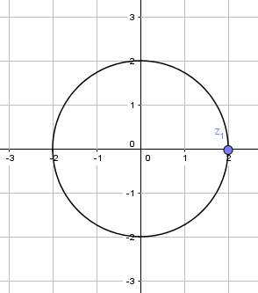
Ex 7 – Geometric Interpretation of Equations and Inequalities in the Complex Plane

- $\left|z\right|=2 \left|x+yi\right|=2$

$$\sqrt{x^{2}+y^{2}}=2$$

$$x^{2}+y^{2}=4 a circle centre \left(0,0\right)and radius 2$$

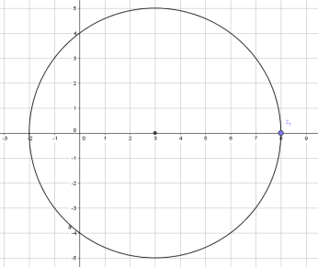
- $\left|z-3\right|=5 \left|x+yi-3\right|=5$
$$\left|(x-3)+yi\right|=5$$
$$\sqrt{{(x-3)}^{2}+y^{2}}=5$$

$${(x-3)}^{2}+y^{2}=25 a circle centre \left(3,0\right)and radius 5$$

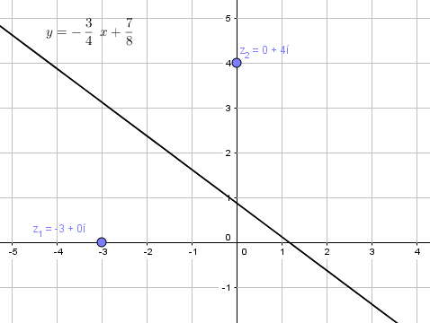
- $\left|z+3\right|=\left|z-4i\right| \left|x+yi+3\right|=\left|x+yi-4i\right|$
$$\left|(x+3)+yi\right|=\left|x+(y-4)i\right|$$

$$\sqrt{{(x+3)}^{2}+y^{2}}=\sqrt{{x^{2}+(y-4)}^{2}}$$

$${(x+3)}^{2}+y^{2}={x^{2}+(y-4)}^{2}$$

$$x^{2}+6x+9+y^{2}=x^{2}+y^{2}-8y+16$$

$$6x+9=-8y+16$$

$$8y=-6x+7$$

$$y=-\frac{3}{4}x+7$$
$$Since-3 is represented by \left(-3,0\right) and 4i is represented by \left(0,4\right), all points representing$$
$$complex numbers z for which \left|z+3\right|=\left|z-4i\right| lie on the line perpendicular bisector of line joining$$
$$\left(-3,0\right) and \left(0,4\right).$$

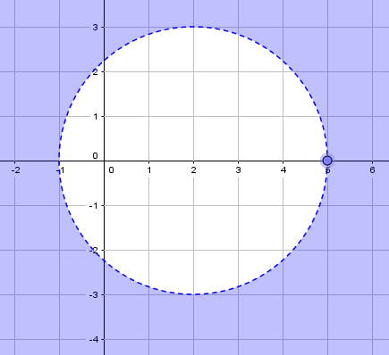
- $\left|z-2\right|>3 \left|x+yi-2\right|>3$

$${(x-2)}^{2}+y^{2}>9$$

$${\left(x-2\right)}^{2}+y^{2}>9$$

$$Outside circle centre \left(2,0\right)and radius>3$$

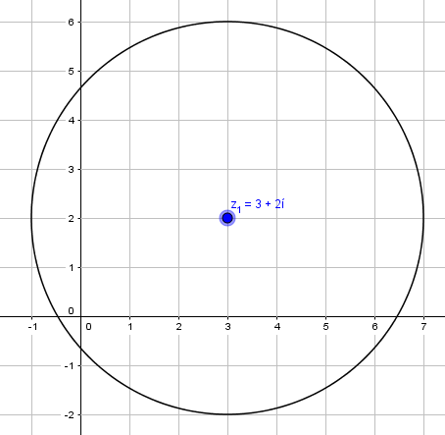
$$\left|z-(3+2i)\right|=4 \left|x+yi-\left(3+2i\right)\right|=4$$

$$\left|\left(x-3\right)+(y+2)i\right|=4$$

$${\left(x-3\right)}^{2}+({y+2)}^{2}=16$$

$$Circle centre \left(3,-2\right)and radius=4$$

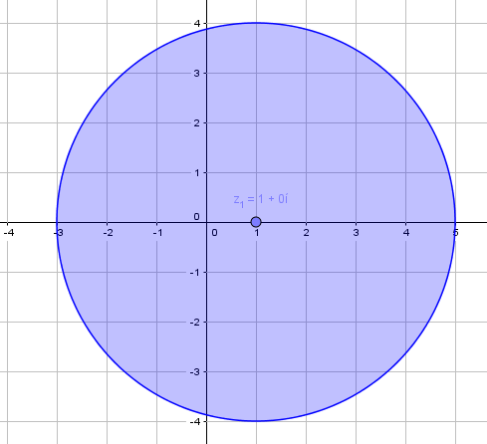
- $\left|z-1\right|≤4 \left|x+yi-1\right|≤4$

$${(x-1)}^{2}+y^{2}≤16$$

$${\left(x-1\right)}^{2}+y^{2}≤16$$

$$Inside and on circle centre \left(1,0\right)and radius>4$$

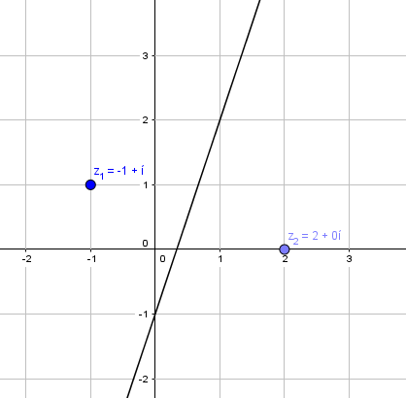

- $\left|z-2\right|=\left|z+1-i\right| \left|x+yi-2\right|=\left|x+yi+1-i\right|$
$$\left|(x-2)+yi\right|=\left|(x+1)+(y-1)i\right|$$
$$\sqrt{{(x-2)}^{2}+y^{2}}=\sqrt{{{(x+1)}^{2}+(y-1)}^{2}}$$

$${(x-2)}^{2}+y^{2}={{(x+1)}^{2}+(y-1)}^{2}$$

$$x^{2}-4x+4+y^{2}=x^{2}+2x+1+y^{2}-2y+1$$

$$2y=6x-2$$

$$y=3x-1$$
$$Since-2 is represented by \left(2,0\right) and 1-i is represented by \left(-1,1\right), all points representing$$
$$complex numbers z for which \left|z+3\right|=\left|z-4i\right| lie on the line perpendicular bisector of line joining$$
$$\left(2,0\right) and \left(-1,1\right).$$

