www.mathsrevision.com
Advanced Higher Maths
Advanced Higher - Unit 3.2 Vector Theory - Solutions

Mr. Lafferty BSC (Hons) Open MathSci & Mrs Bissett BSC (Hons) Glasgow

Ex 1 Revision Higher of 3D Vectors

- $\left(a\right) \underline{b}.\underline{c}+\underline{c}.\underline{a}+\underline{a}.\underline{b}$

$$\underline{b}.\underline{c}=1×0+1×2+2×1=4 ; \underline{c}.\underline{a}=0×1+2×0+1×1=1 ; \underline{a}.\underline{b}=1×1+0×1+1×2=3$$

$$\underline{b}.\underline{c}+\underline{c}.\underline{a}+\underline{a}.\underline{b}=4+1+3=8 ; Scalar$$

$$\left(b\right) \left(\underline{b}.\underline{c}\right)\underline{a}+\left(\underline{c}.\underline{a}\right)\underline{b}+\left(\underline{a}.\underline{b}\right)\underline{c}$$

$$\left(\underline{b}.\underline{c}\right)\underline{a}=4\left(\underline{i}+\underline{k}\right)=4\underline{i}+4\underline{k} ;$$

$$\left(\underline{c}.\underline{a}\right)\underline{b}=1\left(\underline{i}+\underline{j}+2\underline{k}\right)=\underline{i}+\underline{j}+2\underline{k} ;$$

$$\left(\underline{a}.\underline{b}\right)\underline{c}=3\left(2\underline{j}+\underline{k}\right)=6\underline{j}+3\underline{k}$$

$$\left(\underline{b}.\underline{c}\right)\underline{a}+\left(\underline{c}.\underline{a}\right)\underline{b}+\left(\underline{a}.\underline{b}\right)\underline{c}=\left(4\underline{i}+4\underline{k}\right)+\left(\underline{i}+\underline{j}+2\underline{k}\right)+\left(6\underline{j}+3\underline{k}\right)=5\underline{i}+7\underline{j}+9\underline{k} ; Vector$$

$\left(c\right) \left[\left(\underline{b}.\underline{c}\right)\left(\underline{c}.\underline{a}\right)\right]\underline{a}$; $\left(\underline{b}.\underline{c}\right)\left(\underline{c}.\underline{a}\right)=4×1=4 ; \left[\left(\underline{b}.\underline{c}\right)\left(\underline{c}.\underline{a}\right)\right]\underline{a}=4\left(\underline{i}+\underline{k}\right)= 4\underline{i}+4\underline{k} ; Vector$

$$\left(d\right) \left[\left(\underline{b}.\underline{c}\right)\underline{c}+\left(\underline{b}.\underline{a}\right)\underline{a}\right].(\underline{b}+2\underline{a})$$

$$\left(\underline{b}.\underline{c}\right)\underline{c}=4\left(2\underline{j}+\underline{k}\right)=8\underline{j}+4\underline{k} ; \left(\underline{b}.\underline{a}\right)=1×1+1×0+2×1=3 \left(\underline{b}.\underline{a}\right)\underline{a}=3\underline{i}+3\underline{k}$$

$$\left[\left[\left(\underline{b}.\underline{c}\right)\underline{c}+\left(\underline{b}.\underline{a}\right)\right]\underline{a}\right]=\left(8\underline{j}+4\underline{k}\right)+\left(3\underline{i}+3\underline{k}\right)=3\underline{i}+8\underline{j}+7\underline{k}$$

$$\left(\underline{b}+2\underline{a}\right)=\left(\underline{i}+\underline{j}+2\underline{k}\right)+\left(2\underline{i}+2\underline{k}\right)=3\underline{i}+\underline{j}+4\underline{k}$$

$$\left[\left(\underline{b}.\underline{c}\right)\underline{c}+\left(\underline{b}.\underline{a}\right)\underline{a}\right].\left(\underline{b}+2\underline{a}\right)=\left(3\underline{i}+8\underline{j}+7\underline{k}\right).\left(3\underline{i}+\underline{j}+4\underline{k}\right)$$

$$=\left(3\underline{i}+8\underline{j}+7\underline{k}\right).\left(3\underline{i}+\underline{j}+4\underline{k}\right)=3×3+8×1+7×4=45 ; Scalar$$

- $A\left(1,6,-2\right) , B\left(2,5,4\right) , C(4,6,-3)$

$$Length AB=\sqrt{{(2-1)}^{2}+{(5-6)}^{2}+{(4-(-2))}^{2}}=\sqrt{1+1+36}=\sqrt{38}$$

$$Length BC=\sqrt{{(4-2)}^{2}+{(6-5)}^{2}+{(-3-4)}^{2}}=\sqrt{4+1+49}=\sqrt{54}=3\sqrt{6}$$

$$Length AC=\sqrt{{(4-1)}^{2}+{(6-6)}^{2}+{(-3-(-2))}^{2}}=\sqrt{9+0+1}=\sqrt{10}$$

$$\vec{AB}=\left(\begin{matrix}2 \\ 5 \\ 4\end{matrix}\right)-\left(\begin{matrix}1 \\ 6 \\ -2\end{matrix}\right)=\left(\begin{matrix}1 \\ -1 \\ 6\end{matrix}\right) ; \vec{AC}=\left(\begin{matrix}4 \\ 6 \\ -3\end{matrix}\right)-\left(\begin{matrix}1 \\ 6 \\ -2\end{matrix}\right)=\left(\begin{matrix}3 \\ 0 \\ -1\end{matrix}\right)$$

$\vec{AB}.\vec{AC}=1×3+\left(-1\right)×0+6×\left(-1\right)=3+0+\left(-6\right)=-3$

$$cosA=\frac{\vec{AB}.\vec{AC}}{\left|\vec{AB}\right|\left|\vec{AC}\right|}=\frac{-3}{\sqrt{38}×\sqrt{10}}=-\frac{3}{2\sqrt{95}} ; ∠A=98.85°$$

$$\vec{BA}=\left(\begin{matrix}1 \\ 6 \\ -2\end{matrix}\right)-\left(\begin{matrix}2 \\ 5 \\ 4\end{matrix}\right)=\left(\begin{matrix}-1 \\ 1 \\ -6\end{matrix}\right) ; \vec{BC}=\left(\begin{matrix}4 \\ 6 \\ -3\end{matrix}\right)-\left(\begin{matrix}2 \\ 5 \\ 4\end{matrix}\right)=\left(\begin{matrix}2 \\ 1 \\ -7\end{matrix}\right)$$

$\vec{BA}.\vec{BC}=\left(-1\right)×2+1×1+\left(-6\right)×\left(-7\right)=-2+1+42=41$

$$cosB=\frac{\vec{BA}.\vec{BC}}{\left|\vec{BA}\right|\left|\vec{BC}\right|}=\frac{41}{\sqrt{38}×3\sqrt{6}}=\frac{41}{6\sqrt{57}} ; ∠B=25.16°$$

$$\vec{CB}=\left(\begin{matrix}2 \\ 5 \\ 4\end{matrix}\right)-\left(\begin{matrix}4 \\ 6 \\ -3\end{matrix}\right)=\left(\begin{matrix}-2 \\ -1 \\ 7\end{matrix}\right) ; \vec{CA}=\left(\begin{matrix}1 \\ 6 \\ -2\end{matrix}\right)-\left(\begin{matrix}4 \\ 6 \\ -3\end{matrix}\right)=\left(\begin{matrix}-3 \\ 0 \\ 1\end{matrix}\right)$$

$\vec{CB}.\vec{CA}=\left(-2\right)×\left(-3\right)+(-1)×0+7×1=6+0+7=13$

$$cosC=\frac{ \vec{CB}.\vec{CA}}{\left|\vec{CB}\right|\left|\vec{CA}\right|}=\frac{13}{3\sqrt{6}×\sqrt{10}}=\frac{13}{6\sqrt{15}} ; ∠C=55.98°$$

$$AREA=\frac{1}{2}\left|CA\right|\left|CB\right|sinC=\frac{1}{2}×\sqrt{10}×3\sqrt{6}×\frac{\sqrt{{\left(6\sqrt{15}\right)}^{2}-{13}^{2}}}{6\sqrt{15}}=\frac{1}{2}\sqrt{371}=9.63$$

- $Prove {\left|\vec{BD}\right|}^{2}+{\left|\vec{AC}\right|}^{2}=2{\left|\vec{AB}\right|}^{2}+{2\left|\vec{AD}\right|}^{2}$

$\left|\vec{AB}\right|=\left|\vec{CD}\right|=\underline{d} ; \left|\vec{AD}\right|=\left|\vec{BC}\right|=\underline{b} ; \left|\vec{BD}\right|=\underline{b}-\underline{d} ; \vec{AC}=\underline{b}+\underline{d}$

$$LHS={\left|\vec{BD}\right|}^{2}+{\left|\vec{AC}\right|}^{2}= {\left|\underline{b}-\underline{d}\right|}^{2}+{\left|\underline{b}+\underline{d}\right|}^{2} (Note :{\left|\underline{x}\right|}^{2}=\underline{x}.\underline{x}$$

$$LHS={\left|\vec{BD}\right|}^{2}+{\left|\vec{AC}\right|}^{2}= \left(\underline{b}-\underline{d}\right).\left(\underline{b}-\underline{d}\right)+\left(\underline{b}+\underline{d}\right).\left(\underline{b}+\underline{d}\right)$$

$$=\left(\underline{b}.\underline{b}-2\underline{b} .\underline{d}+\underline{d}.\underline{d}\right)+\left(\underline{b}.\underline{b}+2\underline{b} .\underline{d}+\underline{d}.\underline{d}\right)$$

$$=\left(\underline{b}.\underline{b}+\underline{d}.\underline{d}\right)+\left(\underline{b}.\underline{b}+\underline{d}.\underline{d}\right)$$

$$=2{\left|\underline{b}\right|}^{2}+2{\left|\underline{d}\right|}^{2}$$

$$RHS=2{\left|\vec{AB}\right|}^{2}+{2\left|\vec{AD}\right|}^{2}=2{\left|\underline{d}\right|}^{2}+2{\left|\underline{b}\right|}^{2} =2{\left|\underline{b}\right|}^{2}+2{\left|\underline{d}\right|}^{2}=LHS$$

- $Let unit vector be \underline{u}=\left(x\underline{i}+y\underline{j}+z\underline{k}\right) ; \underline{a}=\underline{i} \left(45°\right) and \underline{b}=\underline{k} \left(45°\right)$

$$Using \underline{a}. \underline{u}=\left|\underline{a}\right|×\left|\underline{u}\right|×cosθ°$$

$$x=1×1×cos45° ; x=\frac{1}{\sqrt{2}} (1)$$

$$Using \underline{b}. \underline{u}=\left|\underline{b}\right|×\left|\underline{u}\right|×cosθ°$$

$$z=1×1×cos45° ; z=\frac{1}{\sqrt{2}} (2)$$

$$From equation \left(1\right) and \left(2\right) x=z$$

$$Also \left|\underline{u}\right|=x^{2}+y^{2}+z^{2}=1 ; y^{2}=0 ; y=0$$

$$x=\frac{1}{\sqrt{2}} ; y=0 ; z=\frac{1}{\sqrt{2}} unit vector \left(\frac{1}{\sqrt{2}}\underline{i}+\frac{1}{\sqrt{2}}\underline{k}\right)$$

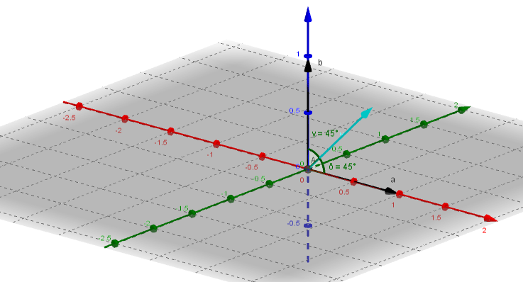

- $Let unit vector be \underline{u}=\left(x\underline{i}+y\underline{j}+z\underline{k}\right) ; \underline{a}=-\underline{i}+\underline{k} \left(45°\right) and \underline{b}=-2\underline{i}+2\underline{j}+\underline{k} \left(60°\right)$

$$Using \underline{a}. \underline{u}=\left|\underline{a}\right|×\left|\underline{u}\right|×cosθ°$$

$$-x+z=\sqrt{2}×1×cos45° ; -x+z=1 (1)$$

$$Using \underline{b}. \underline{u}=\left|\underline{b}\right|×\left|\underline{u}\right|×cosθ°$$

$$-2x+2y+z=3×1×cos60° ; -2x+2y+z=\frac{3}{2} (2)$$

$$From equation \left(1\right) z=1+x$$

$$From equation \left(2\right) -2x+2y+\left(1+x\right)=\frac{3}{2} ; -x+2y=\frac{1}{2} ; y= \frac{1}{4}+\frac{x}{2}$$

$$Also \left|\underline{u}\right|=x^{2}+y^{2}+z^{2}=1 ; x^{2}+{\left(\frac{1}{4}+\frac{x}{2}\right)}^{2}+{\left(1+x\right)}^{2}=1$$

$$x^{2}+\left(\frac{x^{2}}{4}+\frac{x}{4}+\frac{1}{16}\right)+x^{2}+2x+1=1$$

$\frac{{9x}^{2}}{4}+\frac{9x}{4}+\frac{1}{16}=0 ; 36x^{2}+36x+1=0$

$$x=\frac{-36±\sqrt{{36}^{2}-4×36×1}}{72}=\frac{-36±6\sqrt{32}}{72}=\frac{-36±24\sqrt{2}}{72}=\frac{-3±2\sqrt{2}}{6}$$

$$x=\frac{-3+2\sqrt{2}}{6} and x=\frac{-3-2\sqrt{2}}{6}$$

$$For x=\frac{-3+2\sqrt{2}}{6} ; y=\frac{1}{4}+\frac{1}{2}\left(\frac{-3+2\sqrt{2}}{6}\right)=\frac{\sqrt{2}}{6} ; z=1+\left(\frac{-3+2\sqrt{2}}{6}\right)=\frac{3+2\sqrt{2}}{6}$$

$$For x=\frac{-3-2\sqrt{2}}{6} ; y=\frac{1}{4}+\frac{1}{2}\left(\frac{-3-2\sqrt{2}}{6}\right)=-\frac{\sqrt{2}}{6} ; z=1+\left(\frac{-3-2\sqrt{2}}{6}\right)=\frac{3-2\sqrt{2}}{6}$$

$$Unit vectors are \left(\frac{-3+2\sqrt{2}}{6}\underline{i}+\frac{\sqrt{2}}{6}\underline{j}+\frac{3+2\sqrt{2}}{6}\underline{k}\right) and \left(\frac{-3-2\sqrt{2}}{6}\underline{i}-\frac{\sqrt{2}}{6}\underline{j}+\frac{3-2\sqrt{2}}{6}\underline{k}\right)$$

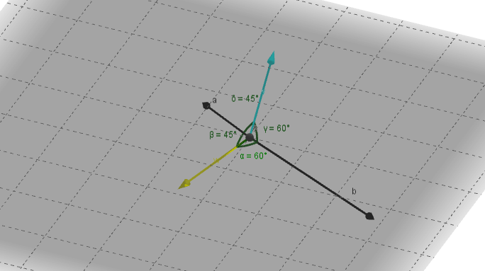

$$\left(b\right) Give vectors {\underline{u}}_{1}=\left(\frac{-3+2\sqrt{2}}{6}\underline{i}+\frac{\sqrt{2}}{6}\underline{j}+\frac{3+2\sqrt{2}}{6}\underline{k}\right) and {\underline{u}}_{2}=\left(\frac{-3-2\sqrt{2}}{6}\underline{i}-\frac{\sqrt{2}}{6}\underline{j}+\frac{3-2\sqrt{2}}{6}\underline{k}\right)$$

$$If perpendicular then {\underline{u}}_{1}.{\underline{u}}_{2}=0$$

$$\frac{\left(-3+2\sqrt{2}\right)}{6}×\frac{\left(-3-2\sqrt{2}\right)}{6}+\frac{\sqrt{2}}{6}×\left(-\frac{\sqrt{2}}{6}\right)+\frac{\left(3+2\sqrt{2}\right)}{6}×\frac{\left(3-2\sqrt{2}\right)}{6}=0$$

$$\frac{\left(9-8\right)}{36}-\frac{2}{36}+\frac{\left(9-8\right)}{36}=\frac{2}{36}-\frac{2}{36}=0 Hence {\underline{u}}_{1} and {\underline{u}}_{2} are perpendicular$$

Ex 2 – Vector Product in Component Form

- $\underline{a}=\left(3\underline{i}+2\underline{j}-\underline{k}\right) \underline{b}=\left(\underline{i}-\underline{j}-2\underline{k}\right) \underline{c}=\left(4\underline{i}-3\underline{j}+4\underline{k}\right)$

$$\left(a\right) \underline{b}×\underline{c}=\left(\underline{i}-\underline{j}-2\underline{k}\right)×\left(4\underline{i}-3\underline{j}+4\underline{k}\right)$$

$$=\left|\begin{matrix}\underline{i} & \underline{j} & \underline{k} \\ 1 & -1 & -2 \\ 4 & -3 & 4\end{matrix}\right|=\left(-10\underline{i}-12\underline{j}+\underline{k}\right)$$

$$\underline{a}×\left(\underline{b}×\underline{c}\right)=\left(3\underline{i}+2\underline{j}-\underline{k}\right)=\left(-10\underline{i}-12\underline{j}+\underline{k}\right)$$

$$=\left|\begin{matrix}\underline{i} & \underline{j} & \underline{k} \\ 3 & 2 & -1 \\ -10 & -12 & 1\end{matrix}\right|=\left(-10\underline{i}+7\underline{j}-16\underline{k}\right)$$

$$\left(b\right) \underline{a}×\underline{b}=\left(3\underline{i}+2\underline{j}-\underline{k}\right)×\left(\underline{i}-\underline{j}-2\underline{k}\right)$$

$$=\left|\begin{matrix}\underline{i} & \underline{j} & \underline{k} \\ 3 & 2 & -1 \\ 1 & -1 & -2\end{matrix}\right|=\left(-5\underline{i}+5\underline{j}-5\underline{k}\right)$$

$$\left(\underline{a}×\underline{b}\right)×\underline{c}=\left(-5\underline{i}+5\underline{j}-5\underline{k}\right)×\left(4\underline{i}-3\underline{j}+4\underline{k}\right)$$

$$=\left|\begin{matrix}\underline{i} & \underline{j} & \underline{k} \\ -5 & 5 & -5 \\ 4 & -3 & 4\end{matrix}\right|=\left(5\underline{i}-0\underline{j}-5\underline{k}\right)=\left(5\underline{i}-5\underline{k}\right)$$

$$\left(c\right) \underline{a}×\underline{b}=\left(-5\underline{i}+5\underline{j}-5\underline{k}\right)$$

$$\underline{a}×\underline{c}=\left|\begin{matrix}\underline{i} & \underline{j} & \underline{k} \\ 3 & 2 & -1 \\ 4 & -3 & 4\end{matrix}\right|=\left(5\underline{i}-16\underline{j}-17\underline{k}\right)$$

$$\left(\underline{a}×\underline{b}\right).\left(\underline{a}×\underline{c}\right)=\left(-5\underline{i}+5\underline{j}-5\underline{k}\right).\left(5\underline{i}-16\underline{j}-17\underline{k}\right)=-25-80+85=-20$$

$\left(d\right) \left(\underline{a}×\underline{b}\right)=\left(-5\underline{i}+5\underline{j}-5\underline{k}\right)$ $\left(\underline{b}×\underline{c}\right)=\left(-10\underline{i}-12\underline{j}+\underline{k}\right)$

$$\left(\underline{a}×\underline{b}\right).\left(\underline{a}×\underline{c}\right)=\left(-5\underline{i}+5\underline{j}-5\underline{k}\right).\left(-10\underline{i}-12\underline{j}+\underline{k}\right)=50-60-5=-15$$

$\left(e\right) \underline{a}× \left(\underline{b}×\underline{c}\right)=\left(-10\underline{i}+7\underline{j}-16\underline{k}\right)$

$$\left[\underline{a}× \left(\underline{b}×\underline{c}\right)\right].\underline{c}=\left(-10\underline{i}+7\underline{j}-16\underline{k}\right).\left(4\underline{i}-3\underline{j}+4\underline{k}\right)=-40-21-64=-125$$

- $\underline{a}=\left(3\underline{i}+2\underline{j}+5\underline{k}\right) \underline{b}=\left(4\underline{i}+3\underline{j}+2\underline{k}\right) \underline{c}=\left(2\underline{i}+\underline{j}+10\underline{k}\right)$

$$\left(a\right) \underline{a}×\underline{b}=\left(3\underline{i}+2\underline{j}+5\underline{k}\right)×\left(4\underline{i}+3\underline{j}+2\underline{k}\right)$$

$$=\left|\begin{matrix}\underline{i} & \underline{j} & \underline{k} \\ 3 & 2 & 5 \\ 4 & 3 & 2\end{matrix}\right|=\left(-11\underline{i}+14\underline{j}+\underline{k}\right)$$

$$\left(b\right) \underline{a}×\underline{c}=\left(3\underline{i}+2\underline{j}+5\underline{k}\right)×\left(2\underline{i}+\underline{j}+10\underline{k}\right)$$

$$\underline{a}×\underline{c}=\left|\begin{matrix}\underline{i} & \underline{j} & \underline{k} \\ 3 & 2 & 5 \\ 2 & 1 & 10\end{matrix}\right|=\left(15\underline{i}-20\underline{j}-\underline{k}\right)$$

$$\underline{b} .\left( \underline{a}×\underline{c}\right)=\left(4\underline{i}+3\underline{j}+2\underline{k}\right)×\left(15\underline{i}-20\underline{j}-\underline{k}\right)=60-60-2=-2$$

$$=\left(-11\underline{i}+14\underline{j}+\underline{k}\right).\left(2\underline{i}+\underline{j}+10\underline{k}\right)=-22+14+10=2$$

$$\left(c\right) \underline{a}×\underline{c}=\left(3\underline{i}+2\underline{j}+5\underline{k}\right)×\left(2\underline{i}+\underline{j}+10\underline{k}\right)$$

$$\underline{a}×\underline{c}=\left|\begin{matrix}\underline{i} & \underline{j} & \underline{k} \\ 3 & 2 & 5 \\ 2 & 1 & 10\end{matrix}\right|=\left(15\underline{i}-20\underline{j}-\underline{k}\right)$$

$$\underline{b} .\left( \underline{a}×\underline{c}\right)=\left(4\underline{i}+3\underline{j}+2\underline{k}\right)×\left(15\underline{i}-20\underline{j}-\underline{k}\right)=60-60-2=-2$$

- $\underline{a}=\left(3\underline{i}+\underline{j}+2\underline{k}\right) \underline{b}=\left(2\underline{j}-\underline{k}\right) \underline{c}=\left(\underline{i}+\underline{j}+\underline{k}\right)$

$\underline{c}×\underline{a}=\left|\begin{matrix}\underline{i} & \underline{j} & \underline{k} \\ 1 & 1 & 1 \\ 3 & 1 & 2\end{matrix}\right|=\left(\underline{i}+\underline{j}-2\underline{k}\right) ; \underline{a} . \underline{c}=\left(3\underline{i}+\underline{j}+2\underline{k}\right). \left(\underline{i}+\underline{j}+\underline{k}\right)=3+1+2=6$

$$\underline{b}×\left(\underline{c}×\underline{a}\right)=\left(2\underline{j}-\underline{k}\right)× \left(\underline{i}+\underline{j}-2\underline{k}\right)$$

$$\underline{b}×\left(\underline{c}×\underline{a}\right)=\left|\begin{matrix}\underline{i} & \underline{j} & \underline{k} \\ 1 & 1 & -2 \\ 0 & 2 & -1\end{matrix}\right|=\left(3\underline{i}+\underline{j}+2\underline{k}\right)$$

$$\left(\underline{a} . \underline{c}\right)\underline{a}=\left(2\underline{j}-\underline{k}\right). \left(\underline{i}+\underline{j}-2\underline{k}\right)=6\left(3\underline{i}+\underline{j}+2\underline{k}\right)=\left(18\underline{i}+6\underline{j}+12\underline{k}\right)$$

$$\underline{d}=\underline{b}×\left(\underline{c}×\underline{a}\right)-\left(\underline{a} . \underline{c}\right)\underline{a}=\left(3\underline{i}+\underline{j}+2\underline{k}\right)-\left(18\underline{i}+6\underline{j}+12\underline{k}\right)=\left(-15\underline{i}-5\underline{j}-10\underline{k}\right)$$

$If \underline{b} and \underline{d} are perpendicular then \underline{b}$.$\underline{d}=0$

$$\underline{b}. \underline{d}=\left(2\underline{j}-\underline{k}\right). \left(-15\underline{i}-5\underline{j}-10\underline{k}\right)=0-10+10=0 ; Hence \underline{b} and \underline{d} are perpendicular$$

- $\underline{a}=\left(4\underline{i}-2\underline{j}+3\underline{k}\right) \underline{b}=\left(5\underline{i}+\underline{j}-4\underline{k}\right)$

$$Vector perpendicular to \underline{a} and \underline{b} is =\underline{a}×\underline{b}$$

$$\underline{a}×\underline{b}=\left|\begin{matrix}\underline{i} & \underline{j} & \underline{k} \\ 4 & -2 & 3 \\ 5 & 1 & -4\end{matrix}\right|=\left(5\underline{i}+31\underline{j}+14\underline{k}\right)$$

- $\underline{a}=\left(\underline{i}+\underline{j}-\underline{k}\right) \underline{b}=\left(2\underline{i}-\underline{j}+\underline{k}\right)$

$$\left(a\right) \underline{a}×\underline{b}=\left|\begin{matrix}\underline{i} & \underline{j} & \underline{k} \\ 1 & 1 & -1 \\ 2 & -1 & 1\end{matrix}\right|=\left(0\underline{i}-3\underline{j}-3\underline{k}\right)=\left(-3\underline{j}-3\underline{k}\right)$$

$$\left(b\right) \underline{a}+\underline{b}=\left(\underline{i}+\underline{j}-\underline{k}\right)+\left(2\underline{i}-\underline{j}+\underline{k}\right)=\left(3\underline{i}\right)$$

$$\underline{a}× \left(\underline{a}+\underline{b}\right)=\left|\begin{matrix}\underline{i} & \underline{j} & \underline{k} \\ 1 & 1 & -1 \\ 3 & 0 & 0\end{matrix}\right|=\left(0\underline{i}-3\underline{j}-3\underline{k}\right)=\left(-3\underline{j}-3\underline{k}\right)$$

$$\left(c\right) \underline{a}.\underline{\left(\underline{a}×\underline{b}\right)}=\left(\underline{i}+\underline{j}-\underline{k}\right).\left(-3\underline{j}-3\underline{k}\right)=0-3+3=0$$

- $\underline{a}=\left(4\underline{i}-\underline{k}\right) \underline{b}=\left(4\underline{i}+3\underline{j}-2\underline{k}\right)$

$$\underline{a}×\underline{b}=\left|\begin{matrix}\underline{i} & \underline{j} & \underline{k} \\ 4 & 0 & -1 \\ 4 & 3 & -2\end{matrix}\right|=\left(3\underline{i}+4\underline{j}+12\underline{k}\right) ; \left|\underline{a}×\underline{b}\right|=\sqrt{3^{2}+4^{2}+{12}^{2}}=±13$$

$$Unit Vectors are \frac{1}{13}\left(3\underline{i}+4\underline{j}+12\underline{k}\right) and -\frac{1}{13}\left(3\underline{i}+4\underline{j}+12\underline{k}\right)$$

- $A\left(4,-8,-13\right) B\left(5,-2,-3\right) C(5,4,10)$

$$\vec{AB}=\left(5\underline{i}-2\underline{j}-3\underline{k}\right)-\left(4\underline{i}-8\underline{j}-13\underline{k}\right)=\left(\underline{i}+6\underline{j}+10\underline{k}\right)$$

$$\vec{AC}=\left(5\underline{i}-4\underline{j}-10\underline{k}\right)-\left(4\underline{i}-8\underline{j}-13\underline{k}\right)=\left(\underline{i}+4\underline{j}+3\underline{k}\right)$$

$$Area of Triangle= \frac{1}{2}\left|\vec{AB}×\vec{AC}\right|$$

$$\vec{AB}×\vec{AC}=\left|\begin{matrix}\underline{i} & \underline{j} & \underline{k} \\ 1 & 6 & 10 \\ 1 & 4 & 3\end{matrix}\right|=\left(-22\underline{i}+7\underline{j}-2\underline{k}\right)$$

$$\left|\vec{AB}×\vec{AC}\right|=\sqrt{{(-22)}^{2}+7^{2}+{\left(-2\right)}^{2}}=\sqrt{537}$$

$$Area of Triangle= \frac{1}{2}\left|\vec{AB}×\vec{AC}\right|=\frac{1}{2}\sqrt{537}=11.6 square units$$

- Leave out !!!

Ex 3 – Vector Equation of a Straight Line
- $\underline{r}=\underline{a}+t\underline{d}=\left(\begin{matrix}x \\ y \\ z\end{matrix}\right)=\left(\begin{matrix}5 \\ -2 \\ 6\end{matrix}\right)+t\left(\begin{matrix}3 \\ 1 \\ 4\end{matrix}\right) ; Symmetrical Form \frac{x-5}{3}=\frac{y+2}{1}=\frac{z-6}{4}$

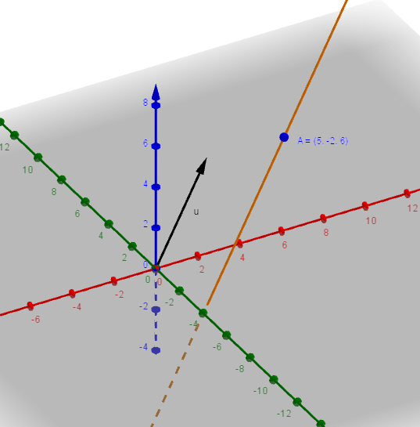

- $\underline{r}=\underline{a}+t\underline{d}=\left(\begin{matrix}x \\ y \\ z\end{matrix}\right)=\left(\begin{matrix}2 \\ -3 \\ -7\end{matrix}\right)+t\left(\begin{matrix}7 \\ 3 \\ -2\end{matrix}\right) ; Symmetrical Form \frac{x-2}{7}=\frac{y+3}{3}=\frac{z+7}{-2}$

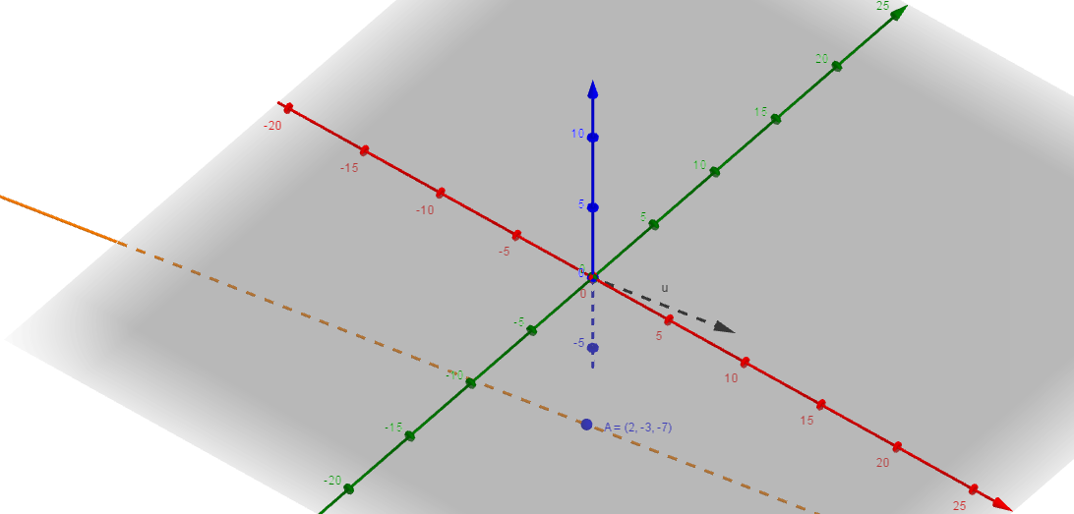

- $\left(a\right) \underline{d}=\underline{b}-\underline{a}=\left(\begin{matrix}5 \\ -13 \\ -4\end{matrix}\right)-\left(\begin{matrix}3 \\ 2 \\ -7\end{matrix}\right)=\left(\begin{matrix}2 \\ -15 \\ 3\end{matrix}\right)$

$$\underline{r}=\underline{a}+t\underline{d}=\left(\begin{matrix}x \\ y \\ z\end{matrix}\right)=\left(\begin{matrix}3 \\ 2 \\ -7\end{matrix}\right)+t\left(\begin{matrix}2 \\ -15 \\ 3\end{matrix}\right) ; Symmetrical Form \frac{x-3}{2}=\frac{y-2}{-15}=\frac{z+7}{3}$$
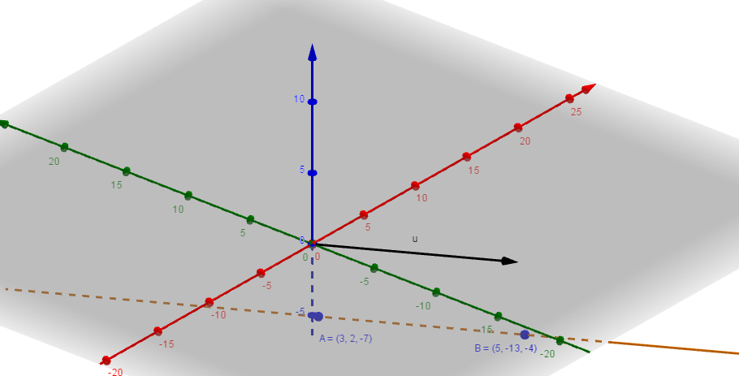

$\left(b\right) \underline{d}=\underline{b}-\underline{a}=\left(\begin{matrix}12 \\ 7 \\ 1\end{matrix}\right)-\left(\begin{matrix}-8 \\ -13 \\ -9\end{matrix}\right)=\left(\begin{matrix}20 \\ 20 \\ 10\end{matrix}\right) ; direction vector reduces to \left(\begin{matrix}2 \\ 2 \\ 1\end{matrix}\right)$
$$\underline{r}=\underline{a}+t\underline{d}=\left(\begin{matrix}x \\ y \\ z\end{matrix}\right)=\left(\begin{matrix}12 \\ 7 \\ 1\end{matrix}\right)+t\left(\begin{matrix}2 \\ 2 \\ 1\end{matrix}\right) ; Symmetrical Form \frac{x-12}{2}=\frac{y-7}{2}=\frac{z-1}{1}$$

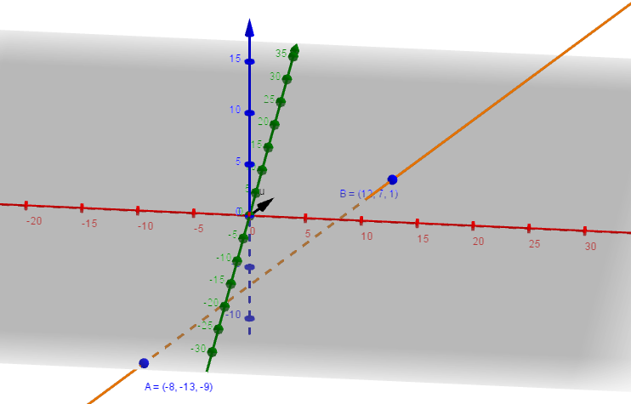

$\left(c\right) \underline{d}=\underline{b}-\underline{a}=\left(\begin{matrix}0 \\ 0 \\ 5\end{matrix}\right)-\left(\begin{matrix}3 \\ 0 \\ 0\end{matrix}\right)=\left(\begin{matrix}-3 \\ 0 \\ 5\end{matrix}\right)$
$$\underline{r}=\underline{a}+t\underline{d}=\left(\begin{matrix}x \\ y \\ z\end{matrix}\right)=\left(\begin{aligned}3 \\ 0 \\ 0\end{aligned}\right)+t\left(\begin{matrix}-3 \\ 0 \\ 5\end{matrix}\right) ; Symmetrical Form \frac{x-3}{-3}=\frac{y}{0}=\frac{z}{5}$$

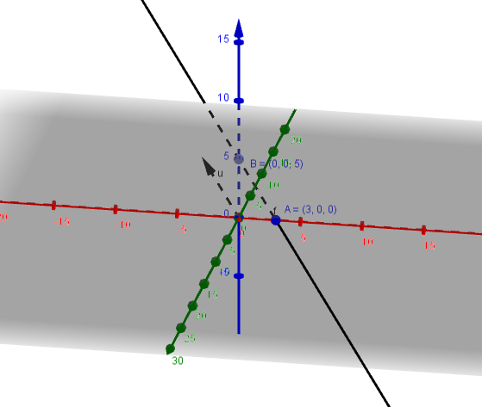

$\left(d\right) \underline{d}=\underline{b}-\underline{a}=\left(\begin{matrix}-10 \\ 4 \\ -6\end{matrix}\right)-\left(\begin{matrix}0 \\ 0 \\ 0\end{matrix}\right)=\left(\begin{matrix}-10 \\ 4 \\ -6\end{matrix}\right) ; direction vector reduces to \left(\begin{matrix}-5 \\ 2 \\ -3\end{matrix}\right)$

$$\underline{r}=\underline{a}+t\underline{d}=\left(\begin{matrix}x \\ y \\ z\end{matrix}\right)=\left(\begin{matrix}0 \\ 0 \\ 0\end{matrix}\right)+t\left(\begin{matrix}-5 \\ 2 \\ -3\end{matrix}\right) ; Symmetrical Form \frac{x}{-5}=\frac{y}{2}=\frac{z}{-3}$$

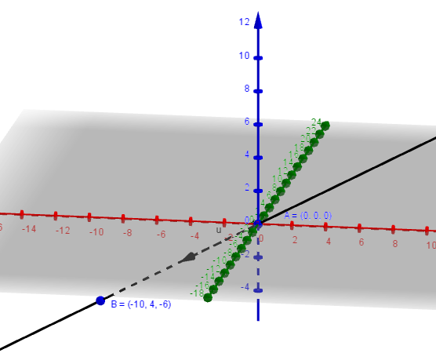

Ex 4 – Vector Equation of a Plane

- $\left(a\right) \underline{n}∙\underline{p}=\left(\begin{matrix}3 \\ -2 \\ 7\end{matrix}\right)∙\left(\begin{matrix}3 \\ -1 \\ 1\end{matrix}\right)=3×3+\left(-2\right)×\left(-1\right)+7×1=18 ; Vec.Eqn 3x-2y+7z=18$
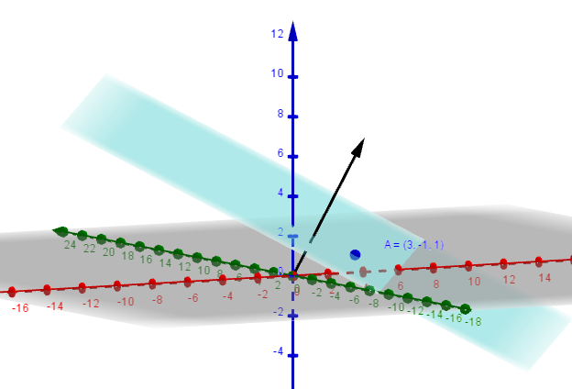
$$\left(b\right) \underline{n}∙\underline{p}=\left(\begin{matrix}2 \\ -1 \\ -1\end{matrix}\right)∙\left(\begin{matrix}4 \\ 1 \\ -2\end{matrix}\right)=2×4+\left(-1\right)×1+\left(-1\right)×\left(-2\right)=9 ; Vec.Eqn 2x-y-z=9$$

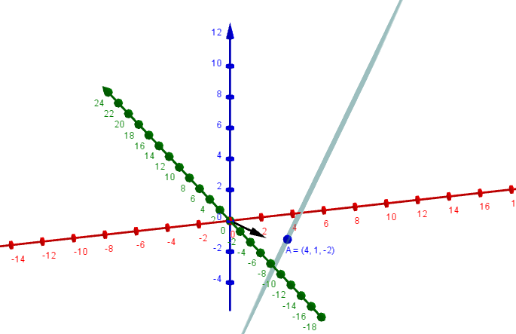

- $\left(a\right) \underline{n}∙\underline{x}=\left(\begin{matrix}a \\ b \\ c\end{matrix}\right)∙\left(\begin{matrix}4 \\ -2 \\ 3\end{matrix}\right)=4a-2b+3c=0 ; \underline{n}∙\underline{x}=\left(\begin{matrix}a \\ b \\ c\end{matrix}\right)∙\left(\begin{matrix}1 \\ 1 \\ 0\end{matrix}\right)=a+b=0$

$$Solving Sim.Eqns \underline{x}=\left(\begin{matrix}a \\ -a \\ -2a\end{matrix}\right)=\left(\begin{matrix}1 \\ -1 \\ -2\end{matrix}\right)$$

$$\underline{n}∙\underline{p}=\left(\begin{matrix}1 \\ -1 \\ -2\end{matrix}\right)∙\left(\begin{matrix}1 \\ 2 \\ -3\end{matrix}\right)=1-2+6=5 ; Cartesian.Eqn x-y-2z=5$$

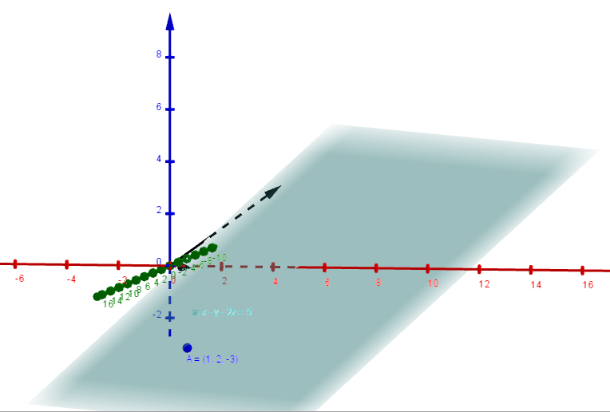

$\left(b\right) \underline{n}∙\underline{x}=\left(\begin{matrix}a \\ b \\ c\end{matrix}\right)∙\left(\begin{matrix}3 \\ -5 \\ -7\end{matrix}\right)=3a-5b-7c=0 ; \underline{n}∙\underline{x}=\left(\begin{matrix}a \\ b \\ c\end{matrix}\right)∙\left(\begin{matrix}-4 \\ -1 \\ 6\end{matrix}\right)=-4a-b+6c=0$
$$b=-4a+6c sub into equation 1 ; 3a-5\left(-4a+6c\right)-7c=0 ; 23a-37c=0$$

$$c=\frac{23}{37}a ; b=-4a+6\left(\frac{23}{37}\right)a=-4a+\frac{138}{37}a ; b=-\frac{10}{37}a$$

$$Solving Sim.Eqns \underline{x}=\left(\begin{matrix}a \\ b \\ c\end{matrix}\right)=\left(\begin{matrix}a \\ -\frac{10}{37}a \\ \frac{23}{37}a\end{matrix}\right) \left(\begin{matrix}37a \\ 37b \\ 37c\end{matrix}\right) =\left(\begin{matrix}37 \\ -10 \\ 23\end{matrix}\right)$$

$$\underline{n}∙\underline{p}=\left(\begin{matrix}1 \\ -1 \\ 1\end{matrix}\right)∙\left(\begin{matrix}37 \\ -10 \\ 23\end{matrix}\right)=37+10+23=70 ; Cartesian.Eqn 37x-10y+23z=70$$

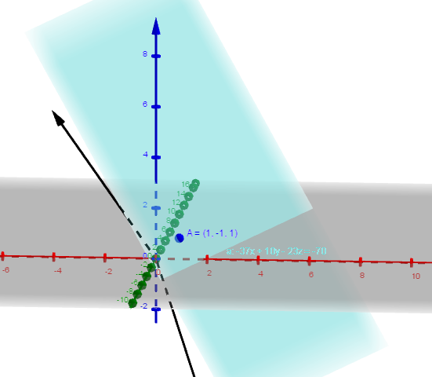

- $\left(a\right) \vec{AB}=\underline{b}-\underline{a}=\left(\begin{matrix}4 \\ 1 \\ 4\end{matrix}\right)-\left(\begin{matrix}2 \\ 1 \\ 3\end{matrix}\right)=\left(\begin{matrix}2 \\ 0 \\ 1\end{matrix}\right) ; \vec{AC}=\underline{c}-\underline{a}=\left(\begin{matrix}2 \\ 3 \\ 6\end{matrix}\right)-\left(\begin{matrix}2 \\ 1 \\ 3\end{matrix}\right)=\left(\begin{matrix}0 \\ 2 \\ 3\end{matrix}\right)$

$$\vec{AB}×\vec{AC}=\left|\begin{matrix}\underline{i} & \underline{j} & \underline{k} \\ 2 & 0 & 1 \\ 0 & 2 & 3\end{matrix}\right|=\left(-2\underline{i}-6\underline{j}+4\underline{k}\right) ; -2x-6y+4z=k$$

$$Sub in a point \left(2,1,3\right) ; -2\left(2\right)-6\left(1\right)+4\left(3\right)=2 ; -2x-6y+4z=2 ; x+3y-2z=-1$$

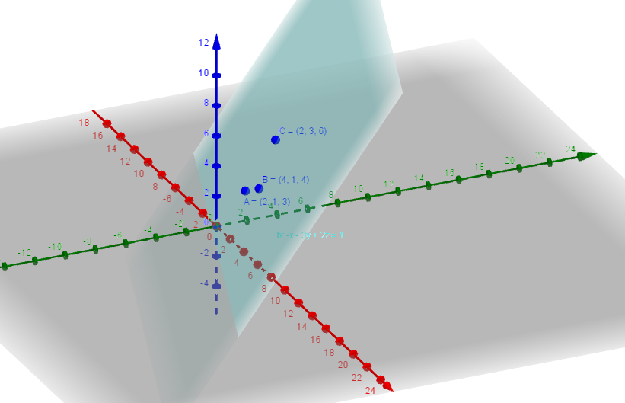

$$\left(b\right) \vec{AB}=\underline{b}-\underline{a}=\left(\begin{matrix}0 \\ 5 \\ 0\end{matrix}\right)-\left(\begin{matrix}3 \\ 0 \\ 0\end{matrix}\right)=\left(\begin{matrix}-3 \\ 5 \\ 0\end{matrix}\right) ; \vec{AC}=\underline{c}-\underline{a}=\left(\begin{matrix}0 \\ 0 \\ 7\end{matrix}\right)-\left(\begin{matrix}3 \\ 0 \\ 0\end{matrix}\right)=\left(\begin{matrix}-3 \\ 0 \\ 7\end{matrix}\right)$$

$$\vec{AB}×\vec{AC}=\left|\begin{matrix}\underline{i} & \underline{j} & \underline{k} \\ -3 & 5 & 0 \\ -3 & 0 & 7\end{matrix}\right|=\left(35\underline{i}+21\underline{j}+15\underline{k}\right) ; 35x+21y+15z=k$$

$$Sub in a point \left(3,0,0\right) ; 35\left(3\right)+21\left(0\right)+15\left(0\right)=105 ; 35x+21y+15z=105$$
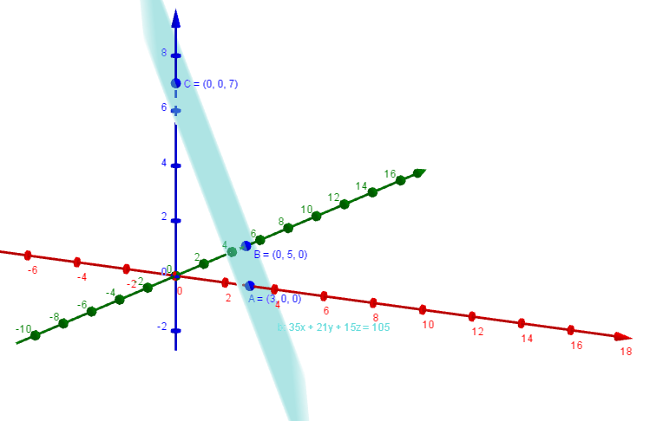

- $\left(a\right) \vec{AB}=\underline{b}-\underline{a}=\left(\begin{matrix}0 \\ 5 \\ -1\end{matrix}\right)-\left(\begin{matrix}5 \\ 8 \\ -4\end{matrix}\right)=\left(\begin{matrix}-5 \\ -3 \\ 3\end{matrix}\right) ; \underline{d}=\left(\begin{matrix}-4 \\ 1 \\ 0\end{matrix}\right)$
$\underline{n}=\vec{AB}×\underline{d}=\left|\begin{matrix}\underline{i} & \underline{j} & \underline{k} \\ -5 & -3 & 3 \\ -4 & 1 & 0\end{matrix}\right|=\left(-3\underline{i}-12\underline{j}-17\underline{k}\right) ; -3x-12y-17z=k$
$\underline{n}∙\underline{p}=\left(\begin{matrix}-3 \\ -12 \\ -17\end{matrix}\right)∙\left(\begin{matrix}5 \\ 8 \\ -4\end{matrix}\right)=-15-96+68=-43 ; Cartesian.Eqn 3x+12y+17z=43$
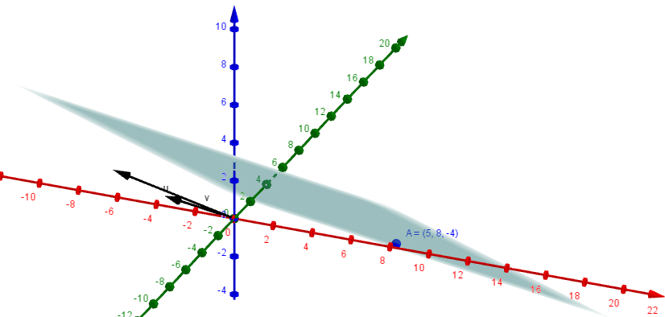

$$\left(b\right) \vec{AB}=\underline{b}-\underline{a}=\left(\begin{matrix}1 \\ -7 \\ 3\end{matrix}\right)-\left(\begin{matrix}2 \\ -5 \\ 3\end{matrix}\right)=\left(\begin{matrix}-1 \\ -2 \\ 0\end{matrix}\right) ; \underline{d}=\left(\begin{matrix}-3 \\ 5 \\ 2\end{matrix}\right)$$
$\underline{n}=\vec{AB}×\underline{d}=\left|\begin{matrix}\underline{i} & \underline{j} & \underline{k} \\ -3 & 5 & 2 \\ -1 & -2 & 0\end{matrix}\right|=\left(4\underline{i}-2\underline{j}+11\underline{k}\right) ; 4x-2y+11z=k$
$\underline{n}∙\underline{p}=\left(\begin{matrix}2 \\ -5 \\ 3\end{matrix}\right)∙\left(\begin{matrix}4 \\ -2 \\ 11\end{matrix}\right)=8+10+33=51 ; Cartesian.Eqn 4x-2y+11z=51$
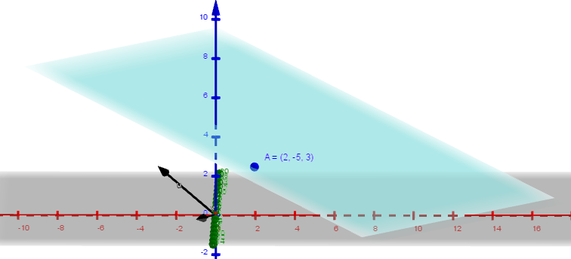

- ${\underline{d}}_{1}=\left(\begin{matrix}2 \\ 3 \\ 4\end{matrix}\right) ; {\underline{d}}_{2} =\left(\begin{matrix}-1 \\ 2 \\ 1\end{matrix}\right)$

$\underline{n}={\underline{d}}_{1}×{\underline{d}}_{2}=\left|\begin{matrix}\underline{i} & \underline{j} & \underline{k} \\ 2 & 3 & 4 \\ -1 & 2 & 1\end{matrix}\right|=\left(-5\underline{i}-6\underline{j}+7\underline{k}\right) ; -5x-6y+7z=k$

$\underline{n}∙\underline{p}=\left(\begin{matrix}-5 \\ -6 \\ 7\end{matrix}\right)∙\left(\begin{matrix}1 \\ 0 \\ -1\end{matrix}\right)=-5-0-7=-12 ; Cartesian.Eqn 5x+6y-7z=12$
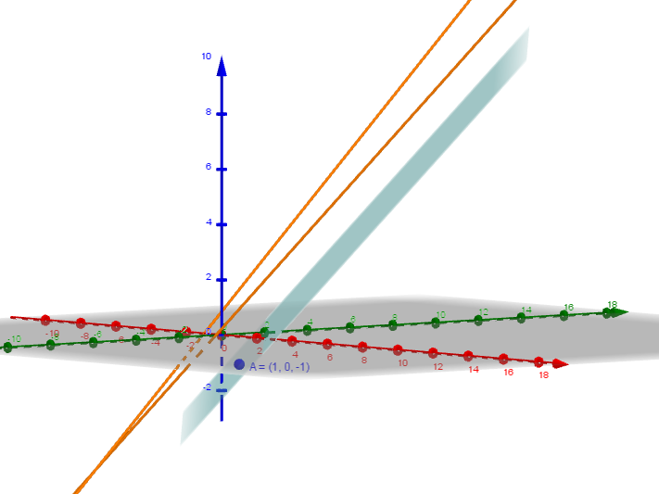

- $\vec{AB}=\underline{b}-\underline{a}=\left(\begin{matrix}1 \\ -1 \\ 0\end{matrix}\right)-\left(\begin{matrix}0 \\ 1 \\ 2\end{matrix}\right)=\left(\begin{matrix}1 \\ -2 \\ -2\end{matrix}\right) ; \underline{d}=\left(\begin{matrix}1 \\ -1 \\ 1\end{matrix}\right)$

$$\underline{n}=\vec{AB}×\underline{d}=\left|\begin{matrix}\underline{i} & \underline{j} & \underline{k} \\ 1 & -2 & -2 \\ 1 & -1 & 1\end{matrix}\right|=\left(-4\underline{i}-3\underline{j}+\underline{k}\right) ; -4x-3y+z=k$$

$$\underline{n}∙\underline{p}=\left(\begin{matrix}-4 \\ -3 \\ 1\end{matrix}\right)∙\left(\begin{matrix}0 \\ 1 \\ 2\end{matrix}\right)=0-3+2=-1 ; Cartesian.Eqn 4x+3y-z=1$$

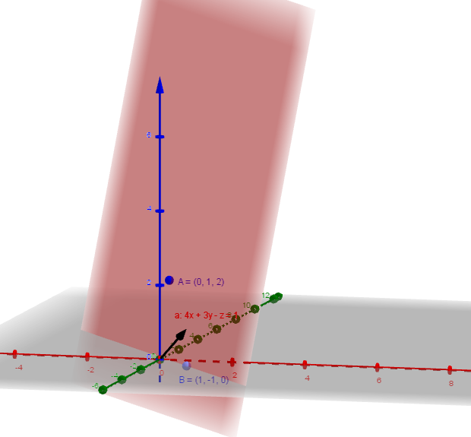

Ex 5 – Angles Intersections between Lines and Planes
- $\left(a\right) {\underline{d}}_{1}=\left(\begin{matrix}1 \\ -2 \\ 2\end{matrix}\right) ; {\underline{d}}_{2} =\left(\begin{matrix}3 \\ 0 \\ -4\end{matrix}\right)$

${\underline{d}}_{1}.{\underline{d}}_{2}=\left(\begin{matrix}1 \\ -2 \\ 2\end{matrix}\right).\left(\begin{matrix}3 \\ 0 \\ -4\end{matrix}\right)=3+0-8=-5 ; \left|{\underline{d}}_{1}\right|=3 \left|{\underline{d}}_{2}\right|=5$

$$cosθ=\frac{{\underline{d}}_{1}.{\underline{d}}_{2}}{\left|{\underline{d}}_{1}\right|\left|{\underline{d}}_{2}\right|}=\frac{-5}{3×5}=110° ; Acute angle is 70°$$
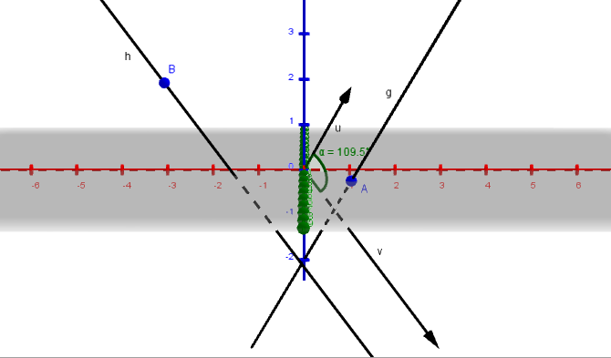
$$\left(b\right) {\underline{d}}_{1}=\left(\begin{matrix}1 \\ 1 \\ 1\end{matrix}\right) ; {\underline{d}}_{2} =\left(\begin{matrix}1 \\ 5 \\ -1\end{matrix}\right)$$

${\underline{d}}_{1}.{\underline{d}}_{2}=\left(\begin{matrix}1 \\ 1 \\ 1\end{matrix}\right).\left(\begin{matrix}1 \\ 5 \\ -1\end{matrix}\right)=1+5-1=5 ; \left|{\underline{d}}_{1}\right|=\sqrt{3} \left|{\underline{d}}_{2}\right|=\sqrt{27}$

$$cosθ=\frac{{\underline{d}}_{1}.{\underline{d}}_{2}}{\left|{\underline{d}}_{1}\right|\left|{\underline{d}}_{2}\right|}=\frac{5}{\sqrt{3}×\sqrt{27}}=56°$$
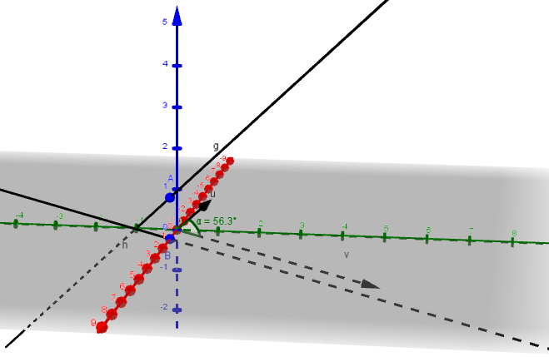

$$\left(c\right) {\underline{d}}_{1}=\left(\begin{matrix}3 \\ 5 \\ 4\end{matrix}\right) ; {\underline{d}}_{2} =\left(\begin{matrix}1 \\ 1 \\ 2\end{matrix}\right)$$

${\underline{d}}_{1}.{\underline{d}}_{2}=\left(\begin{matrix}3 \\ 5 \\ 4\end{matrix}\right).\left(\begin{matrix}1 \\ 1 \\ 2\end{matrix}\right)=3+5+8=16 ; \left|{\underline{d}}_{1}\right|=\sqrt{50} \left|{\underline{d}}_{2}\right|=\sqrt{6}$

$$cosθ=\frac{{\underline{d}}_{1}.{\underline{d}}_{2}}{\left|{\underline{d}}_{1}\right|\left|{\underline{d}}_{2}\right|}=\frac{16}{\sqrt{50}×\sqrt{6}}=22.5°$$
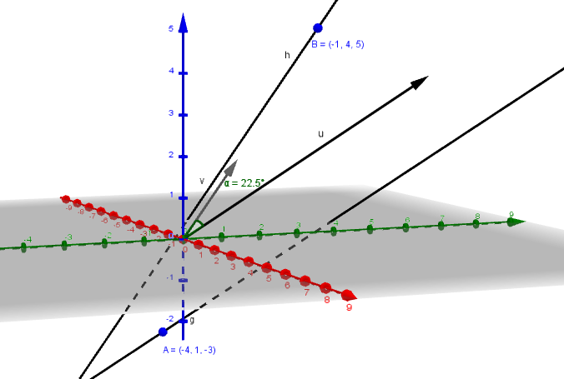
$$\left(d\right) {\underline{d}}_{1}=\left(\begin{matrix}1 \\ 2 \\ -2\end{matrix}\right) ; {\underline{d}}_{2} =\left(\begin{matrix}-2 \\ -4 \\ 4\end{matrix}\right)$$
${\underline{d}}_{1}.{\underline{d}}_{2}=\left(\begin{matrix}1 \\ 2 \\ -2\end{matrix}\right).\left(\begin{matrix}-2 \\ -4 \\ 4\end{matrix}\right)=-2-8-8=-18 ; \left|{\underline{d}}_{1}\right|=3 \left|{\underline{d}}_{2}\right|=6$

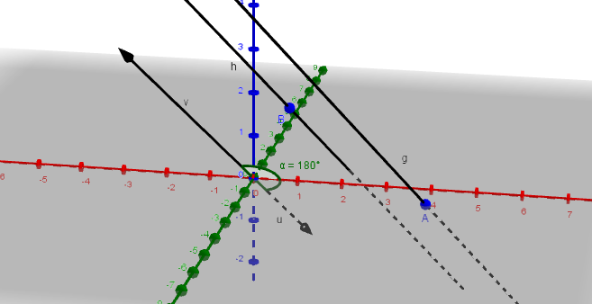
$cosθ=\frac{{\underline{d}}_{1}.{\underline{d}}_{2}}{\left|{\underline{d}}_{1}\right|\left|{\underline{d}}_{2}\right|}=\frac{-18}{3×6}=180° ; Acute angle is 0°$

- $\left(a\right) {\underline{d}}_{1}=\left(\begin{matrix}2 \\ 2 \\ -3\end{matrix}\right) ; {\underline{d}}_{2} =\left(\begin{matrix}1 \\ 3 \\ -4\end{matrix}\right)$

${\underline{d}}_{1}.{\underline{d}}_{2}=\left(\begin{matrix}2 \\ 2 \\ -3\end{matrix}\right).\left(\begin{matrix}1 \\ 3 \\ -4\end{matrix}\right)=2+6+12=20 ; \left|{\underline{d}}_{1}\right|=\sqrt{17} \left|{\underline{d}}_{2}\right|=\sqrt{26}$

$$cosθ=\frac{{\underline{d}}_{1}.{\underline{d}}_{2}}{\left|{\underline{d}}_{1}\right|\left|{\underline{d}}_{2}\right|}=\frac{20}{\sqrt{17}×\sqrt{26}}=18°$$
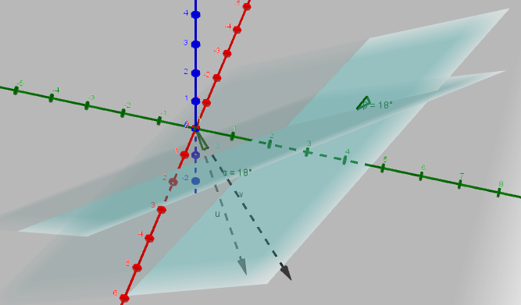
$$\left(b\right) {\underline{d}}_{1}=\left(\begin{matrix}5 \\ -14 \\ 2\end{matrix}\right) ; {\underline{d}}_{2} =\left(\begin{matrix}6 \\ 7 \\ 6\end{matrix}\right)$$

${\underline{d}}_{1}.{\underline{d}}_{2}=\left(\begin{matrix}5 \\ -14 \\ 2\end{matrix}\right).\left(\begin{matrix}6 \\ 7 \\ 6\end{matrix}\right)=30-98+12=-56 ; \left|{\underline{d}}_{1}\right|=15 \left|{\underline{d}}_{2}\right|=11$
$$cosθ=\frac{{\underline{d}}_{1}.{\underline{d}}_{2}}{\left|{\underline{d}}_{1}\right|\left|{\underline{d}}_{2}\right|}=\frac{-56}{15×11}=109.8° ; Acute angle is 70.2°$$
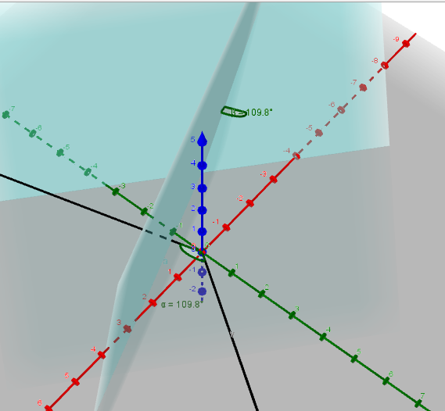

$$\left(c\right) {\underline{d}}_{1}=\left(\begin{matrix}1 \\ -1 \\ 0\end{matrix}\right) ; {\underline{d}}_{2} =\left(\begin{matrix}0 \\ 1 \\ 1\end{matrix}\right)$$

${\underline{d}}_{1}.{\underline{d}}_{2}=\left(\begin{matrix}1 \\ -1 \\ 0\end{matrix}\right).\left(\begin{matrix}0 \\ 1 \\ 1\end{matrix}\right)=0+1+0=-1 ; \left|{\underline{d}}_{1}\right|=\sqrt{2} \left|{\underline{d}}_{2}\right|=\sqrt{2}$

$$cosθ=\frac{{\underline{d}}_{1}.{\underline{d}}_{2}}{\left|{\underline{d}}_{1}\right|\left|{\underline{d}}_{2}\right|}=\frac{-1}{\sqrt{2}×\sqrt{2}}=120° ; Acute angle is 60°$$
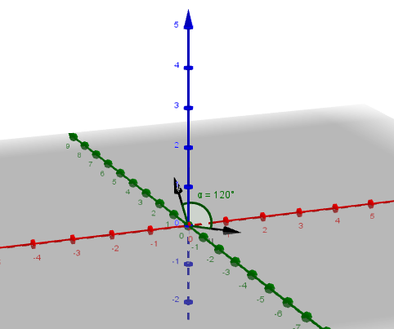
$$\left(d\right) {\underline{d}}_{1}=\left(\begin{matrix}1 \\ 1 \\ 1\end{matrix}\right) ; {\underline{d}}_{2} =\left(\begin{matrix}1 \\ -1 \\ 1\end{matrix}\right)$$

${\underline{d}}_{1}.{\underline{d}}_{2}=\left(\begin{matrix}1 \\ 1 \\ 1\end{matrix}\right).\left(\begin{matrix}1 \\ -1 \\ 1\end{matrix}\right)=1-1+1=1 ; \left|{\underline{d}}_{1}\right|=\sqrt{3} \left|{\underline{d}}_{2}\right|=\sqrt{3}$
$$cosθ=\frac{{\underline{d}}_{1}.{\underline{d}}_{2}}{\left|{\underline{d}}_{1}\right|\left|{\underline{d}}_{2}\right|}=\frac{1}{\sqrt{3}×\sqrt{3}}=70.5°$$
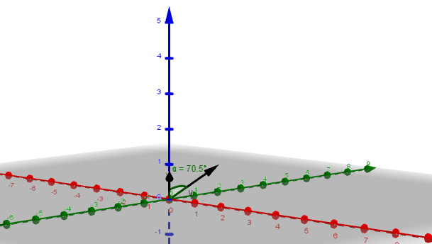

- $\left(a\right) {\underline{d}}_{1}=\left(\begin{matrix}4 \\ -1 \\ -5\end{matrix}\right) ; {\underline{d}}_{2} =\left(\begin{matrix}1 \\ -2 \\ 4\end{matrix}\right)$
${\underline{d}}_{1}.{\underline{d}}_{2}=\left(\begin{matrix}4 \\ -1 \\ -5\end{matrix}\right).\left(\begin{matrix}1 \\ -2 \\ 4\end{matrix}\right)=4+2-20=-14 ; \left|{\underline{d}}_{1}\right|=\sqrt{42} \left|{\underline{d}}_{2}\right|=\sqrt{21}$
$$cosθ=\frac{{\underline{d}}_{1}.{\underline{d}}_{2}}{\left|{\underline{d}}_{1}\right|\left|{\underline{d}}_{2}\right|}=\frac{-14}{\sqrt{42}×\sqrt{21}}=118.5° ; Acute angle is 61.5° angle \left(90-61.5\right)=28.5°$$
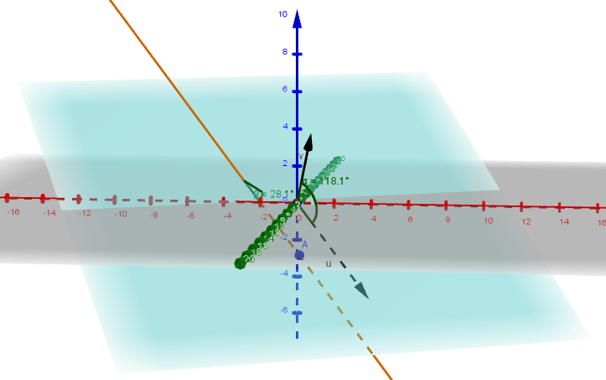
$$\left(b\right) {\underline{d}}_{1}=\left(\begin{matrix}2 \\ 6 \\ 3\end{matrix}\right) ; {\underline{d}}_{2} =\left(\begin{matrix}2 \\ -1 \\ -2\end{matrix}\right)$$
${\underline{d}}_{1}.{\underline{d}}_{2}=\left(\begin{matrix}2 \\ 6 \\ 3\end{matrix}\right).\left(\begin{matrix}2 \\ -1 \\ -2\end{matrix}\right)=4-6-6=-8 ; \left|{\underline{d}}_{1}\right|=7 \left|{\underline{d}}_{2}\right|=3$
$$cosθ=\frac{{\underline{d}}_{1}.{\underline{d}}_{2}}{\left|{\underline{d}}_{1}\right|\left|{\underline{d}}_{2}\right|}=\frac{-8}{7×3}=112.4° ; Acute angle is 67.6° angle \left(90-67.6\right)=22.4°$$
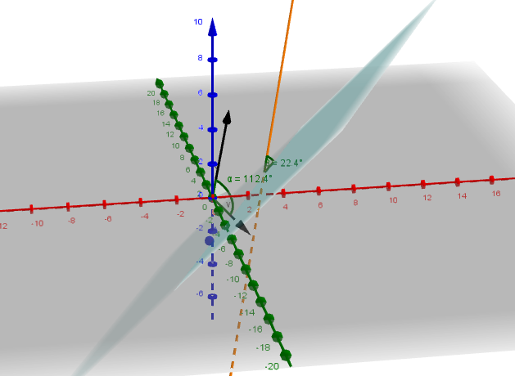

$$\left(c\right) {\underline{d}}_{1}=\left(\begin{matrix}2 \\ 3 \\ 6\end{matrix}\right) ; {\underline{d}}_{2} =\left(\begin{matrix}10 \\ 2 \\ -11\end{matrix}\right)$$
${\underline{d}}_{1}.{\underline{d}}_{2}=\left(\begin{matrix}2 \\ 3 \\ 6\end{matrix}\right).\left(\begin{matrix}10 \\ 2 \\ -11\end{matrix}\right)=20+6-66=-40 ; \left|{\underline{d}}_{1}\right|=7 \left|{\underline{d}}_{2}\right|=15$

$$cosθ=\frac{{\underline{d}}_{1}.{\underline{d}}_{2}}{\left|{\underline{d}}_{1}\right|\left|{\underline{d}}_{2}\right|}=\frac{-40}{7×15}=112.4° ; Acute angle is 67.6° angle \left(90-67.6\right)=22.4°$$
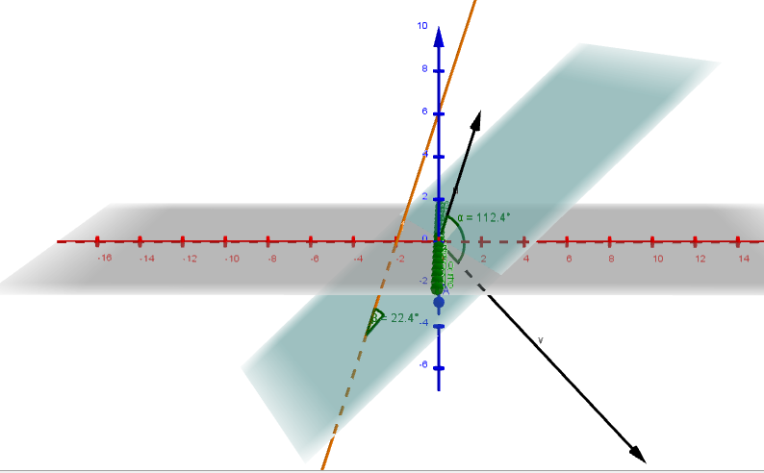
$$\left(d\right) {\underline{d}}_{1}=\left(\begin{matrix}1 \\ 1 \\ 1\end{matrix}\right) ; {\underline{d}}_{2} =\left(\begin{matrix}1 \\ -2 \\ 2\end{matrix}\right)$$
${\underline{d}}_{1}.{\underline{d}}_{2}=\left(\begin{matrix}1 \\ 1 \\ 1\end{matrix}\right).\left(\begin{matrix}1 \\ -2 \\ 2\end{matrix}\right)=1-2+2=1 ; \left|{\underline{d}}_{1}\right|=\sqrt{3} \left|{\underline{d}}_{2}\right|=3$
$$cosθ=\frac{{\underline{d}}_{1}.{\underline{d}}_{2}}{\left|{\underline{d}}_{1}\right|\left|{\underline{d}}_{2}\right|}=\frac{1}{\sqrt{3}×3}=78.9° ; angle \left(90-78.9\right)=11.1°$$
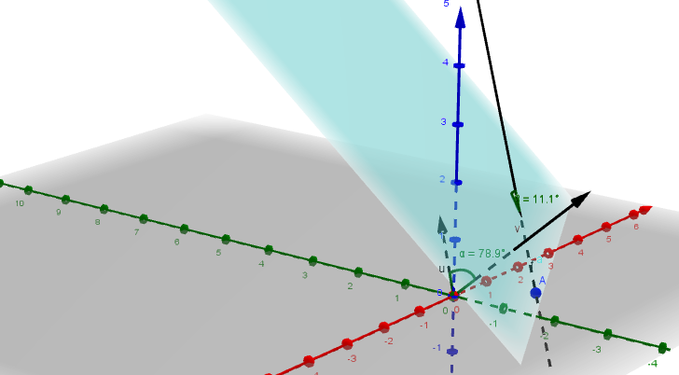

- $\left(a\right) P\left(p,q,r\right) ; \frac{p-4}{1}=λ \frac{p-7}{6}=μ ; λ+4=6μ+7 ; λ-6μ=3$

$$; \frac{q-8}{2}=λ \frac{q-6}{4}=μ ; 2λ+8=4μ+6 ; λ-2μ=-1$$

$$; \frac{r-3}{1}=λ \frac{r-5}{5}=μ ; λ+3=5μ+5 ; λ-5μ=2$$

$$Solve sim.equations ; λ=-3 and μ=-1 ; Point is (1,2,0)$$

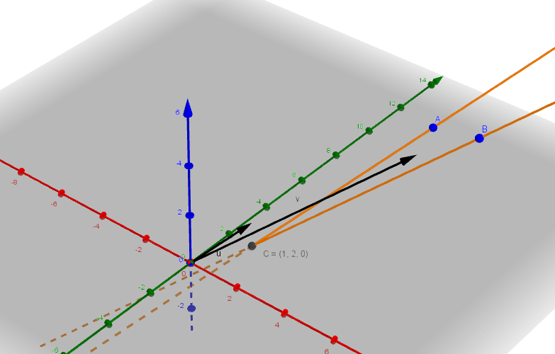

$$\left(b\right) P\left(p,q,r\right) ; \frac{p-2}{1}=λ \frac{p+3}{-1}=μ ; λ+2=-μ-3 ; λ+μ=-5$$

$$; \frac{q-9}{2}=λ \frac{q-7}{2}=μ ; 2λ+9=2μ+7 ; λ-μ=-1$$

$$; \frac{r-13}{3}=λ \frac{r+2}{-3}=μ ; 3λ+13=-3μ-2 ; λ+μ=-5$$

$$Solve sim.equations ; λ=-3 and μ=-2 ; Point is (-1,3,4)$$

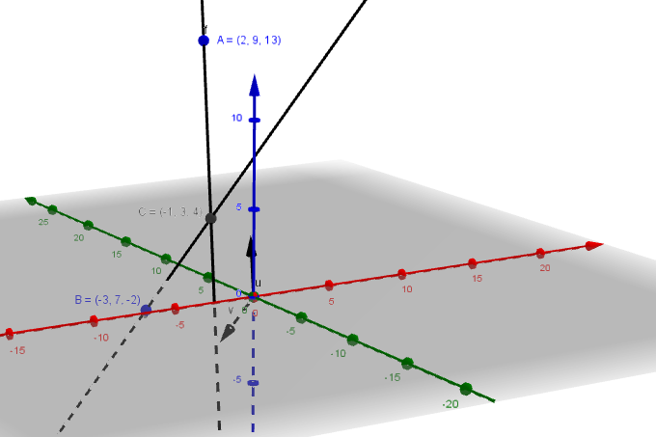

- $\left(a\right) x+y+2z=2 and x-y-z=5$

$$Eliminating y from the equations by adding gives ; 2x+z=7 ; z=-2x+7$$

$$From equation 2 ; y=x-z-5$$

$$Let x=t ; z=-2t+7 ; y=t-\left(-2t+7\right)-5 y=3t-12$$

$Line \frac{x}{1}=\frac{y+12}{3}= \frac{z-7}{-2} ; other formats are possible !$

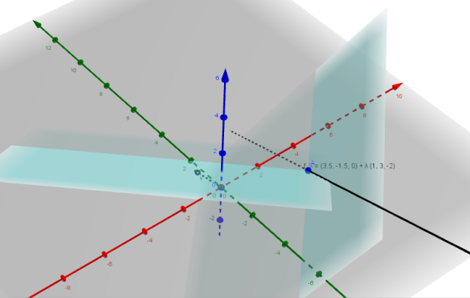

$$\left(b\right) 2x-y=3 and x+y+4z=1$$
$$Eliminating y from the equations by adding gives ; 3x+4z=4 ; x=-\frac{4}{3}z+\frac{4}{3}$$

$$From equation 1 ; y=2x-3$$

$$Let z=t ; x=-\frac{4}{3}t+\frac{4}{3} ; y=2\left(-\frac{4}{3}t+\frac{4}{3}\right)-3 y=-\frac{8}{3}t-\frac{1}{3}$$

$\frac{x-\frac{4}{3}}{-\frac{4}{3}}=\frac{y+\frac{1}{3}}{-\frac{8}{3}}=\frac{z}{1} ; multiply through by a \frac{1}{3}$

$$Line \frac{x-\frac{4}{3}}{-4}=\frac{y+\frac{1}{3}}{-8}= \frac{z}{3} ; all formats are possible !$$
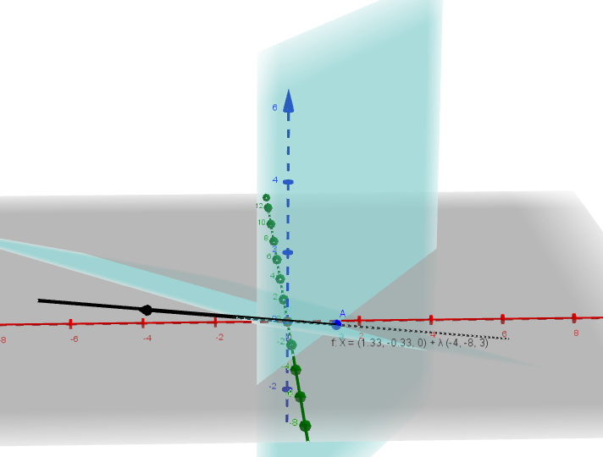

$$\left(c\right) A: 2x+3y+z=8 B: x+y+z=10 C: 3x+5y+z=6$$

$$The normal vector of A : \underline{a}=\left(\begin{matrix}2 \\ 3 \\ 1\end{matrix}\right)$$

$$The normal vector of B : \underline{b}=\left(\begin{matrix}1 \\ 1 \\ 1\end{matrix}\right)$$

$$The normal vector of C : \underline{c}=\left(\begin{matrix}3 \\ 5 \\ 1\end{matrix}\right)$$

$The direction vector of the line of intersection of A and B is parallel to \underline{a}×\underline{b}$

$\underline{a}×\underline{b}=\left|\begin{matrix}\underline{i} & \underline{j} & \underline{k} \\ 2 & 3 & 1 \\ 1 & 1 & 1\end{matrix}\right|=\left(\begin{matrix}2 \\ -1 \\ -1\end{matrix}\right)$

$$If \left(\underline{a}×\underline{b}\right).\underline{c} =0,$$

$$the direction vector of the line of intersection is perpendicular to the normal vector of the plane C.$$

$$i.e. the three plane intersect on a line.$$

$$Let z=0 , A:2x+3y=8 B: x+y=10 C: 3x+5y=6$$

$$x=22 y=-12 Hence point on the intersection line is (22,-12,0)$$

$$The point also satifies C, since 3x+5y+z=6 ; 3(22)+5(-12)+0=6$$

$$The line equation is \frac{x-22}{2}=\frac{y+12}{-1}=\frac{z}{-1}$$

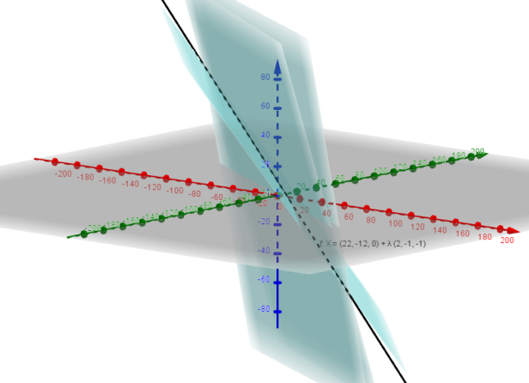

- $\left(a\right) Sub in for x,y and z in equation 2$

$2\left(4+t\right)+4\left(1-t\right)+3t=9 ; 8+2t+4-4t+3t=9$

$t+12=9 ; t=-3$

$x=4+\left(-3\right)=1 ; y=1-t=1-\left(-3\right)=4 ; z=3t=3×-3=-9$

$Coordinate is (1,4,-9)$
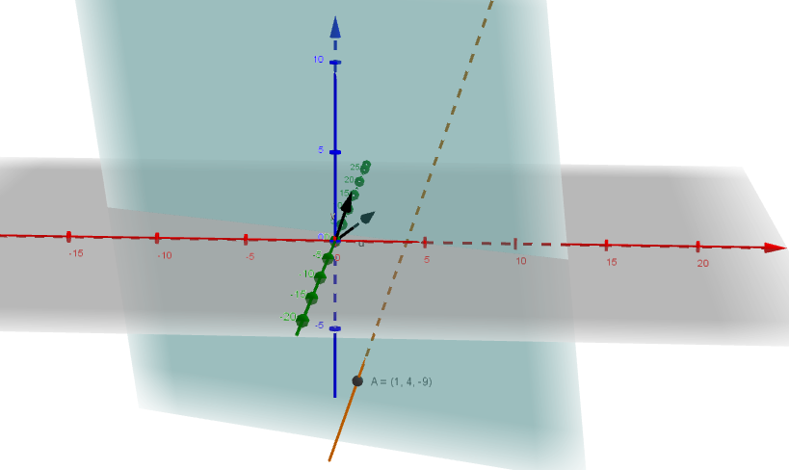

$$\left(b\right) Rearrange equation 1 into t=$$

$x=3t+1 ; y=t+2 ; z=4t+1$

$Sub x,y and z into equation 2$

$\left(3t+1\right)-2\left(t+2\right)+3\left(4t+1\right)=26 ; 3t+1-2t-4+12t+3=26$

$13t=26 ; t=2$

$x=3×2+1=7 ; y=2+2=4 ; z=4×2+1=9$

$Coordinate is (7,4,9)$
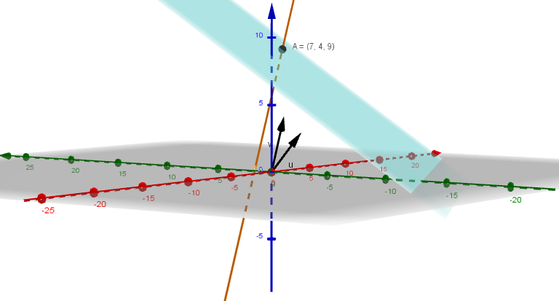

- $P \left(1,2,1\right) line direction {\underline{d}}_{1}=\left(1,-1,2\right) Plane direction {\underline{d}}_{2}=(1,2,3)$

$$\underline{n}={\underline{d}}_{1}×{\underline{d}}_{2}=\left|\begin{matrix}\underline{i} & \underline{j} & \underline{k} \\ 1 & -1 & 2 \\ 1 & 2 & 3\end{matrix}\right|=\left(-7\underline{i}-\underline{j}+3\underline{k}\right) ; -7x-y+3z=k$$
$$\underline{n}.\underline{p}=\left(\begin{matrix}-7 \\ -1 \\ 3\end{matrix}\right).\left(\begin{matrix}1 \\ 2 \\ 1\end{matrix}\right)=-7-2+3=-6 ; -7x-y+3z=-6 ; 7x+y-3z=6$$
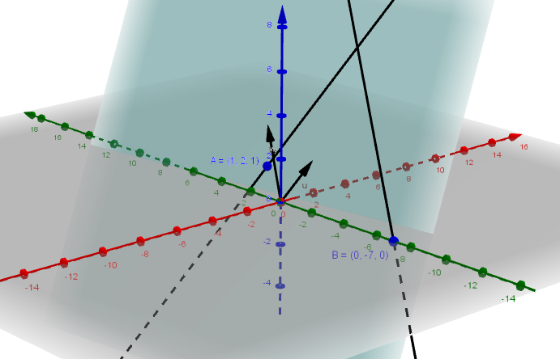

- $\left(a\right) Rearrange line equation into t=$

$x=2t-1 ; y=-t+2 ; z=2t-3$

$Sub x,y and z into plane$

$3\left(2t-1\right)-\left(-t+2\right)+\left(2t-3\right)=10 ; 6t-3+t-2+2t-3=10$

$9t=18 ; t=2$

$x=2×2-1=3 ; y=-2+2=0 ; z=2×2-3=1$

$Coordinate is (3,0,1)$

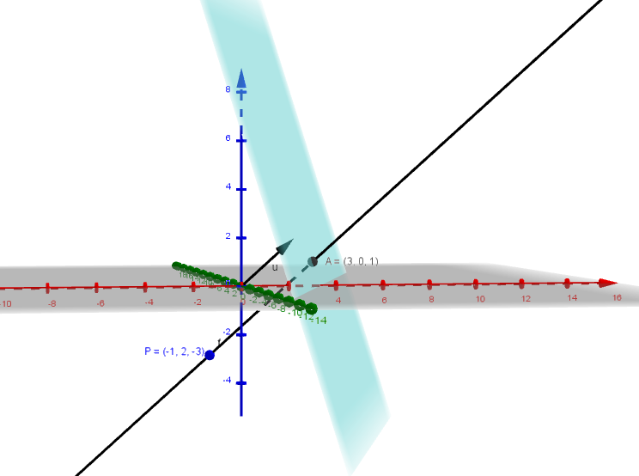

$$\left(b\right) {\underline{d}}_{1}=\left(2,-1,2\right) Plane direction {\underline{d}}_{2}=(3,-1,1)$$

$$\underline{n}={\underline{d}}_{1}×{\underline{d}}_{2}=\left|\begin{matrix}\underline{i} & \underline{j} & \underline{k} \\ 2 & -1 & 2 \\ 3 & -1 & 1\end{matrix}\right|=\left(\underline{i}+4\underline{j}+\underline{k}\right) ; -7x-y+3z=k$$

$$\underline{r}=\underline{a}+t\underline{d}=\left(\begin{matrix}x \\ y \\ z\end{matrix}\right)=\left(\begin{matrix}3 \\ 0 \\ 1\end{matrix}\right)+t\left(\begin{matrix}1 \\ 4 \\ 1\end{matrix}\right) ; Symmetrical Form \frac{x-3}{1}=\frac{y}{4}=\frac{z-1}{1}$$
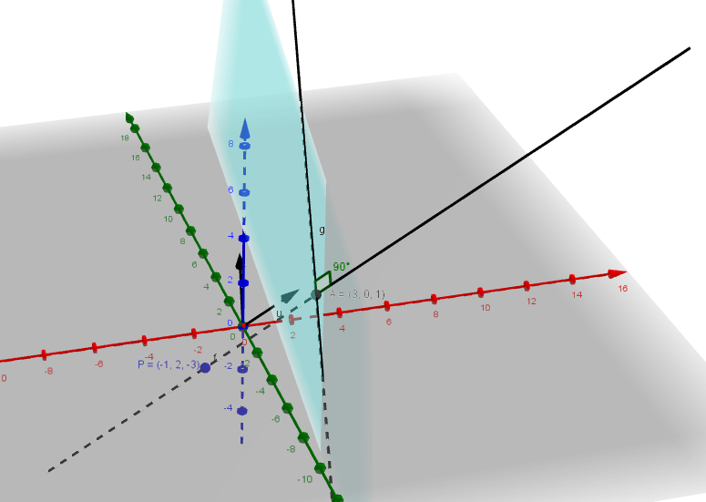

- $(a) \vec{AB}=\underline{b}-\underline{a}=\left(\begin{matrix}4 \\ 0 \\ -5\end{matrix}\right)-\left(\begin{matrix}2 \\ -4 \\ 3\end{matrix}\right)=\left(\begin{matrix}2 \\ 4 \\ -8\end{matrix}\right) ; direction vector reduces to \underline{d}=\left(\begin{matrix}1 \\ 2 \\ -4\end{matrix}\right)$

$$\underline{r}=\underline{a}+t\underline{d}=\left(\begin{matrix}x \\ y \\ z\end{matrix}\right)=\left(\begin{matrix}2 \\ -4 \\ 3\end{matrix}\right)+t\left(\begin{matrix}1 \\ 2 \\ -4\end{matrix}\right) ; Parametric form x=2+t ; y=-4+2t ; z=3-4t$$

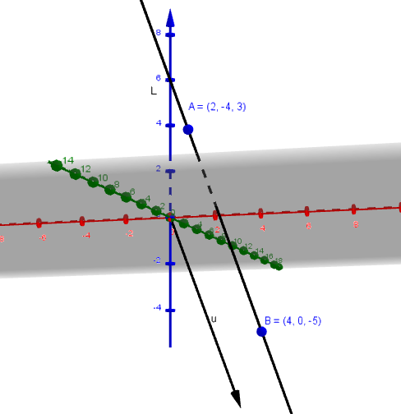

$$(b) \vec{AC}=\underline{b}-\underline{a}=\left(\begin{matrix}-2 \\ -6 \\ 1\end{matrix}\right)-\left(\begin{matrix}2 \\ -4 \\ 3\end{matrix}\right)=\left(\begin{matrix}-4 \\ -2 \\ -2\end{matrix}\right) ; direction vector reduces to \underline{d}=\left(\begin{matrix}2 \\ 1 \\ 1\end{matrix}\right)$$
$$If ⊥then {\underline{d}}_{1}.{\underline{d}}_{2}=0 ; \left(\begin{matrix}2 \\ 1 \\ 1\end{matrix}\right).\left(\begin{matrix}1 \\ 2 \\ -4\end{matrix}\right)=2+2-4=0 ; Hence L is ⊥M$$

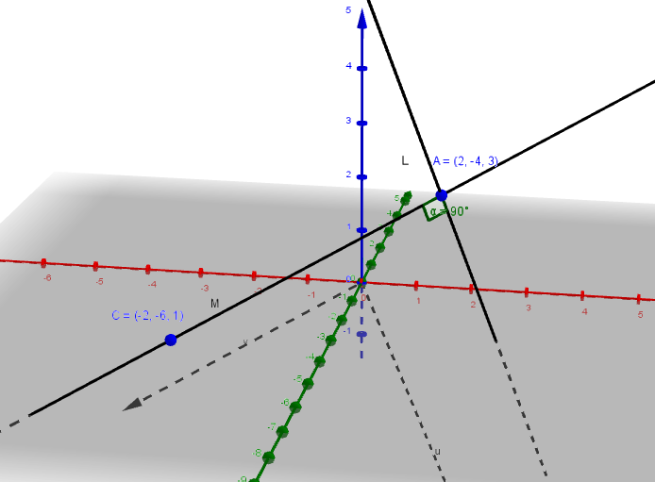

$$\left(c\right) Plane containing L amd M$$

$${\underline{d}}_{1}=\left(2,1,1\right) Plane direction {\underline{d}}_{2}=(1,2,-4)$$

$$\underline{n}={\underline{d}}_{1}×{\underline{d}}_{2}=\left|\begin{matrix}\underline{i} & \underline{j} & \underline{k} \\ 2 & 1 & 1 \\ 1 & 2 & -4\end{matrix}\right|=\left(-6\underline{i}+9\underline{j}+3\underline{k}\right) ; -6x+9y+3z=k$$

$$\underline{n}.\underline{p}=k ; \left(\begin{matrix}-6 \\ 9 \\ 3\end{matrix}\right).\left(\begin{matrix}2 \\ -4 \\ 3\end{matrix}\right)=-12-36+9=-39 ; -6x+9y+3z=-39$$

$$2x-3y-z=13$$

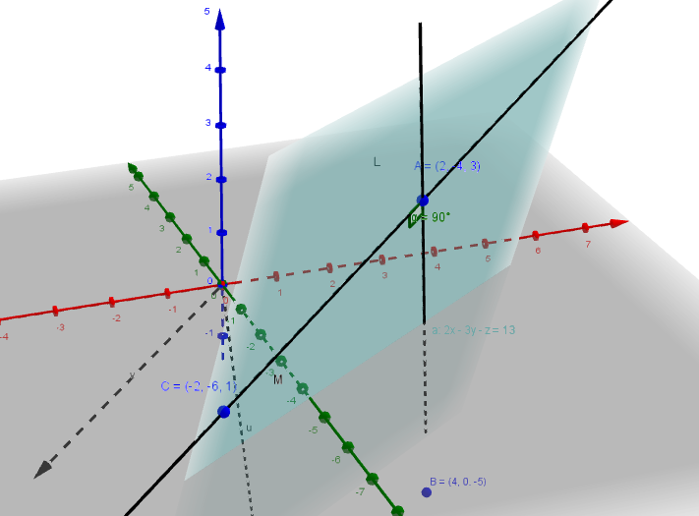

- $\left(a\right) L parametric equations x=2-t ; y=-3+2t ; z=-1-4t$

$Sub x,y and z into plane 2x+3y+z=-6$

$L.H.S 2\left(2-t\right)+3\left(-3+2t\right)+\left(-1-4t\right)= 4-2t-9+6t-1-4t=-6=R.H.S$

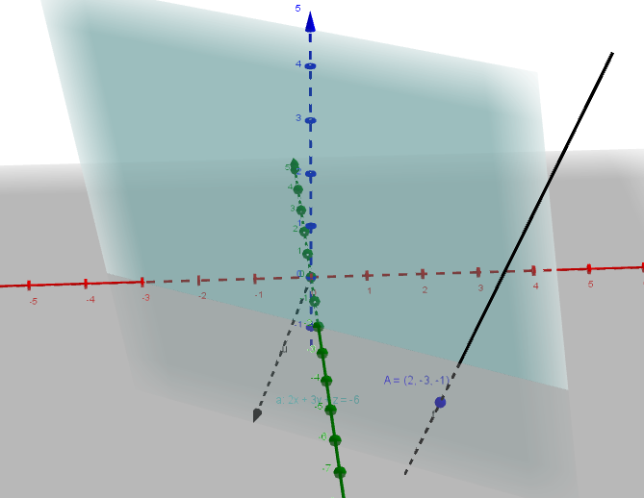

$$\left(b\right) \underline{r}=\underline{a}+t\underline{d}=\left(\begin{matrix}x \\ y \\ z\end{matrix}\right)=\left(\begin{matrix}3 \\ 2 \\ -4\end{matrix}\right)+t\left(\begin{matrix}2 \\ 3 \\ 1\end{matrix}\right) ; x=3+2t y=2+3t z=-4+t$$

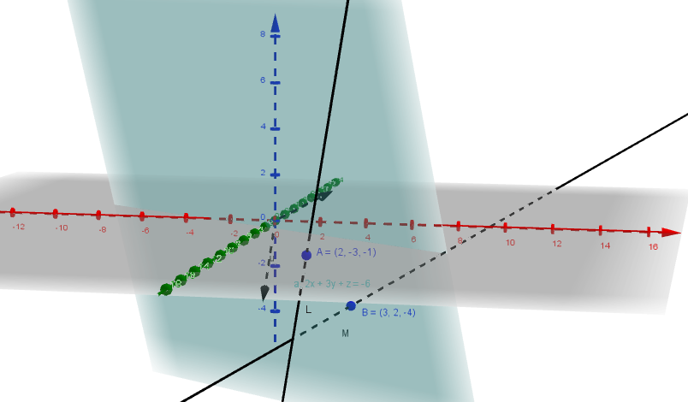

$\left(c\right) Sub x,y and z into plane 2x+3y+z=-6$

$2\left(3+2t\right)+3\left(2+3t\right)+\left(-4+t\right)=-6 ; 6+4t+6+9t-4+t=-6$

$8+14t=-6 ; t=-1$

$x=3+2×\left(-1\right)=1 ; y=2+3×\left(-1\right)=-1 ; z=-4+\left(-1\right)=-5$

$Intersection Point between M and the Plane is (1,-1,-5)$

$If \left(1,-1,-5\right) lies on L then it will satisfy L equations.$

$$1=2-t ⇒t=1 ; -1=-3+2t ⇒t=1 ; -5=-1-4t ⇒t=1$$

$Hence \left(1,-1,-5\right) lies on L.$

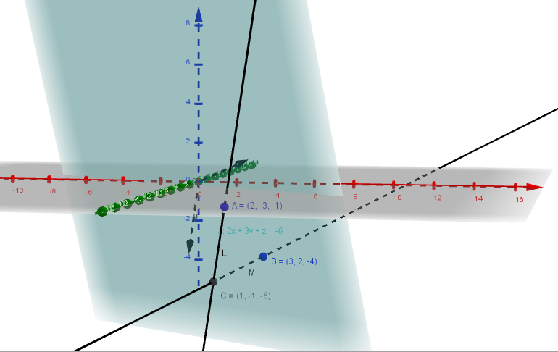

- $(a) \vec{AB}=\underline{b}-\underline{a}=\left(\begin{matrix}3 \\ -2 \\ 1\end{matrix}\right)-\left(\begin{matrix}2 \\ 1 \\ -1\end{matrix}\right)=\left(\begin{matrix}1 \\ -3 \\ 2\end{matrix}\right) ; direction vector \underline{d_{1}}=\left(\begin{matrix}1 \\ -3 \\ 2\end{matrix}\right)$

$$\underline{r}=\underline{a}+t\underline{d}=\left(\begin{matrix}x \\ y \\ z\end{matrix}\right)=\left(\begin{matrix}2 \\ 1 \\ -1\end{matrix}\right)+t\left(\begin{matrix}1 \\ -3 \\ 2\end{matrix}\right)$$

$$L Parametric form x=2+t ; y=-4+2t ; z=3-4t$$

$$M Parametric form x=11+4t ; y=3+2t ; z=1+t$$

$$\frac{x-11}{4}=\frac{y-3}{2}=\frac{z-1}{1} direction vector \underline{d_{2}}=\left(\begin{matrix}4 \\ 2 \\ 1\end{matrix}\right)$$

$$If LM ⊥then {\underline{d}}_{1}.{\underline{d}}_{2}=0 ; \left(\begin{matrix}1 \\ -3 \\ 2\end{matrix}\right).\left(\begin{matrix}4 \\ 2 \\ 1\end{matrix}\right)=4-6+2=0 ; Hence L is ⊥to M$$

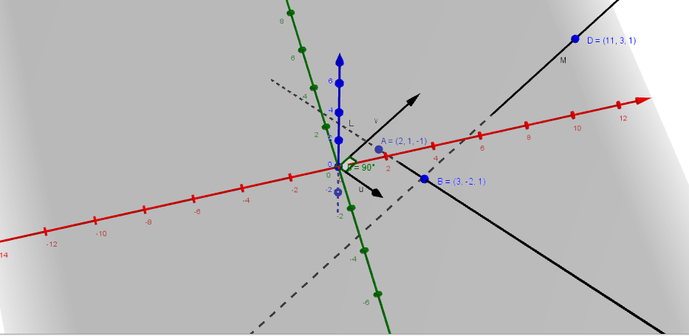

$$\left(b\right) P\left(2,1,-1\right) \underline{d_{2}}=\left(\begin{matrix}4 \\ 2 \\ 1\end{matrix}\right) direction of M$$

$Plane is ⊥to M we have 4x+2y+z=k$
$\underline{n}.\underline{p}=k ; \left(\begin{aligned}4 \\ 2 \\ 1\end{aligned}\right).\left(\begin{matrix}2 \\ 1 \\ 2\end{matrix}\right)=8+2-1=9 ; 4x+2y+z=9$
$Plane and line M intersect at C M : x=11+4t ; y=3+2t ; z=1+t$
$Sub x,y and z into plane 4x+2y+z=9$
$4\left(11+4t\right)+2\left(3+2t\right)+\left(1+t\right)=-6 ; 44+16t+6+4t+1+t=9$

$51+21t=9 ; t=-2$

$x=11+4×\left(-2\right)=3 ; y=3+2×\left(-2\right)=-1 ; z=1+\left(-2\right)=-1$

$Intersection Point C between M and the Plane is (3,-1,-1)$

$$A(2,1,-1) B(3,-2,1) C(3,-1,-1)$$

$$Distance AC=\sqrt{{(x_{2}-x_{1})}^{2}+{\left(y_{2}-y_{1}\right)}^{2}+{\left(z_{2}-z_{1}\right)}^{2}}$$

$$Distance AC=\sqrt{{(3-2)}^{2}+{\left(-1-1\right)}^{2}+{\left(-1-(-1)\right)}^{2}}=\sqrt{1+4+0}=\sqrt{5}$$

$$Distance BC=\sqrt{{(x_{2}-x_{1})}^{2}+{\left(y_{2}-y_{1}\right)}^{2}+{\left(z_{2}-z_{1}\right)}^{2}}$$

$$Distance BC=\sqrt{{(3-3)}^{2}+{\left(-1-(-2)\right)}^{2}+{\left(-1-1\right)}^{2}}=\sqrt{0+1+4}=\sqrt{5}$$

$$Hence C is equidistant from A and B.$$
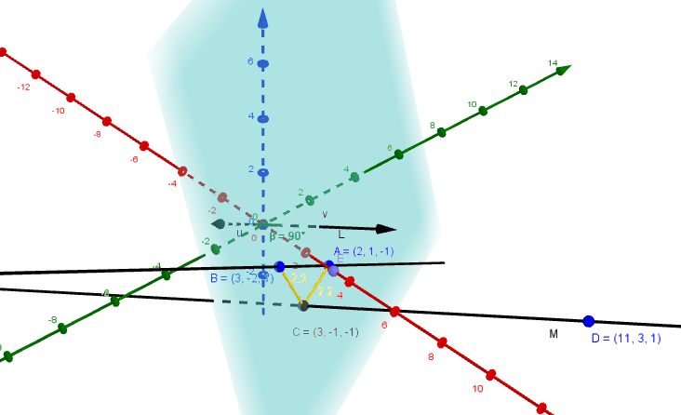

- $\left(a\right) \vec{AB}=\underline{b}-\underline{a}=\left(\begin{matrix}4 \\ 5 \\ -7\end{matrix}\right)-\left(\begin{matrix}1 \\ -1 \\ 2\end{matrix}\right)=\left(\begin{matrix}3 \\ 6 \\ -9\end{matrix}\right) ; direction vector reduces to \underline{d_{1}}=\left(\begin{matrix}1 \\ 2 \\ -3\end{matrix}\right)$

$\underline{r}=\underline{a}+t\underline{d}=\left(\begin{matrix}x \\ y \\ z\end{matrix}\right)=\left(\begin{matrix}1 \\ -1 \\ 2\end{matrix}\right)+t\left(\begin{matrix}1 \\ 2 \\ -3\end{matrix}\right)$

$$Parametric form x=1+t ; y=-1+2t ; z=2-3t$$

$$\frac{x-1}{1}=\frac{y+1}{2}=\frac{z-2}{-3}$$

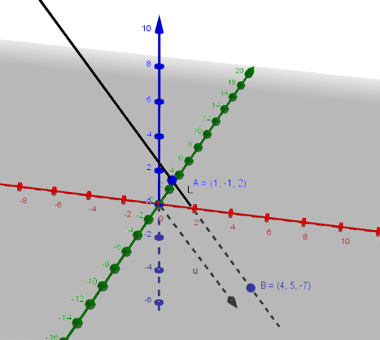

$$\left(b\right) Parametric form x=6+4t ; y=2+t ; z=1+2t$$

$$\frac{x-6}{4}=\frac{y-2}{1}=\frac{z-1}{2} direction vector \underline{d_{2}}=\left(\begin{matrix}4 \\ 1 \\ 2\end{matrix}\right)$$
$$If lines are ⊥then {\underline{d}}_{1}.{\underline{d}}_{2}=0 ; \left(\begin{matrix}1 \\ 2 \\ -3\end{matrix}\right).\left(\begin{matrix}4 \\ 1 \\ 2\end{matrix}\right)=4+2-6=0 ; Hence Lines are ⊥$$

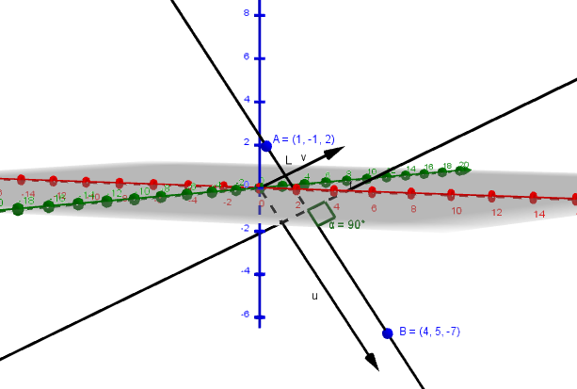

$$\left(c\right) P\left(p,q,r\right) ; \frac{p-1}{1}=λ \frac{p-6}{4}=μ ; λ+1=4μ+6 ; λ-4μ=5$$

$$; \frac{q+1}{2}=λ \frac{q-2}{1}=μ ; 2λ-1=μ+2 ; 2λ-μ=3$$

$$; \frac{r-2}{-3}=λ \frac{r-1}{2}=μ ; -3λ+2=2μ+1 ; 3λ+2μ=1$$

$$Solve sim.equations ; λ=1 and μ=-1 ; Point is (2,1,-1)$$

