Q1. A survey of S3 pupils on how many times they visited the cinema in the last month is given below.

Complete the table below and calculate:
- Range
- Mean
- Mode
- Median

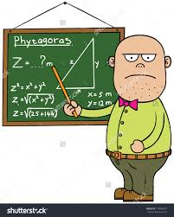
Q2. In a school, the average age of three mathematics teachers is 48.
A new mathematics teacher arrives and the new average is 51.

What is the age of the new mathematics teacher ?

Q3. Complete the table below and calculate the median.

Marking Scheme
Q1 | $$\left(i\right) Range = 5$$  $$\left(ii\right) Mean = 1.06$$  $$\left(iii\right) Mode = 0$$  $$\left(ii\right) Median = 15$$ | - 5  - Totals + 3rd column correct 2 marks  (2 out of 3 1 mark)  - 1.06  - 0  - 1
Q2 | 60 | - 144  - $204$  - 204 - 144 = 60
Q3 | 3 books | - $Cumulative Frequancy all correct$  - 13th number  - $Median=3 book$
Total 12 marks

