H

Mathematics Time allowed
Higher 1 hour 10 minutes
Paper 2
Practice Paper F
NATIONAL
QUALIFICATIONS

Read carefully

1 Calculators may be used in this paper.
2 Full credit will be given only where the solution contains appropriate working.
3 Answers obtained by readings from scale drawings will not receive any credit.

© Mathematics Matters 2008
FORMULAE LIST
Circle:
The equation 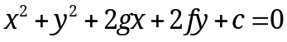 represents a circle centre 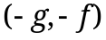 and radius 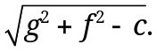
The equation 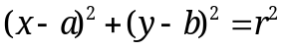 represents a circle centre 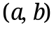 and radius r.

Scalar Product : 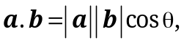 where is the angle between a and b.
or 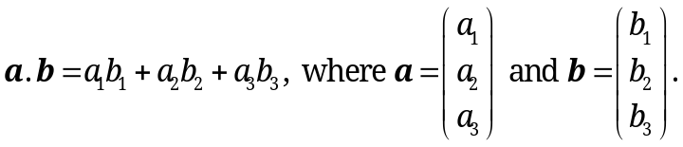

Trigonometric formulae: 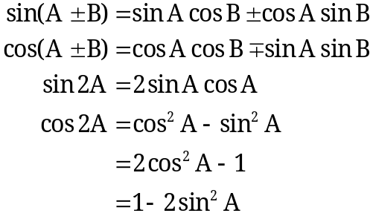

Table of standard derivatives :
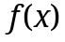 | 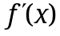
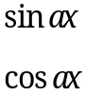 | 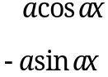

Table of standard integrals :
 | 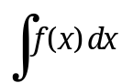
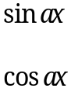 | 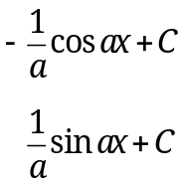

ALL questions should be attempted.
Marks
1. (a) Find the equation of the tangent to the curve 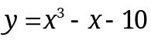 at the point
where 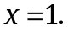 5
(b) Show that this line is also a tangent to the circle with equation
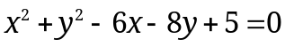
and state the coordinates of the point of contact. 6

y
A
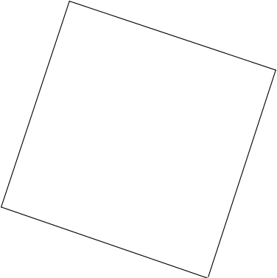
2. The diagram opposite shows a rhombus ABCD.
AC and BD are diagonals of the
rhombus.
B
Diagonal AC has equation 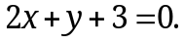
E
D is point with coordinates 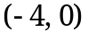.
E is the point of intersection of the diagonals.
x
0
D
C

(a) Find the equation of diagonal BD. 4
(b) Hence find the coordinates of E. 2

3. Given that 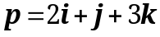 and 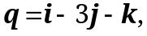 find the angle between p and q. 5

4. If 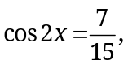 find the exact value of :
(a) 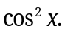 2
(b) 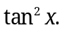 3

Marks
5. A sequence is defined by the recurrence relation 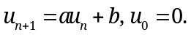
(a) If 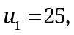 write down the value of b. 1
(b) Given that 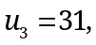 find the possible values of a. 4
This sequence tends to a limit as
(c) Find the limit of the sequence. 2

6. (a) Express 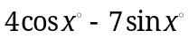 in the form 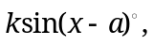 where 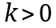 and 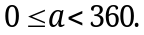 4
(b) Hence solve 4

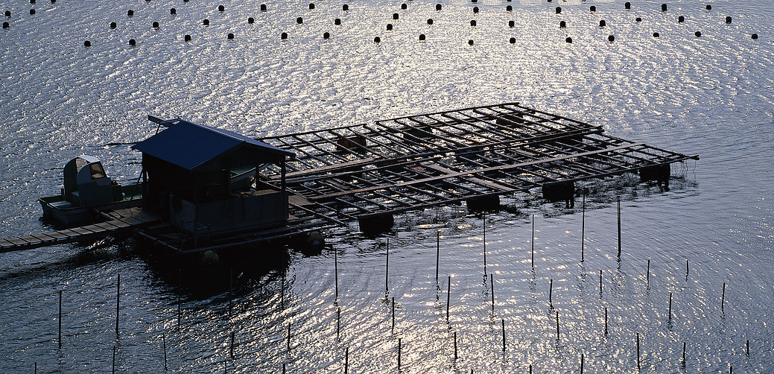
7. A new fish farm is being established
consisting of a number of rectangular
enclosures.

Each enclosure is made up from eight

identical rectangular cages.

Each cage measures x metres by y metres.

The total length of edging around the top of all
of the caging is 480 metres.
y
x

(a) Show that the total surface area, in square metres, of the top of the eight
cages is given by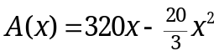. 3
(b) (i) Find the value of x which maximises this surface area.
(ii) Hence find the dimensions of each enclosure. 7

Marks
y
8. The diagram shows the graphs of
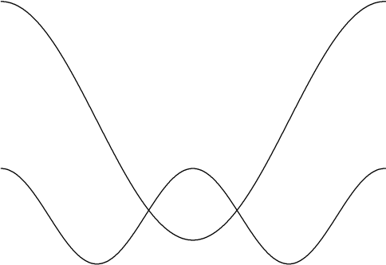
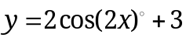 and 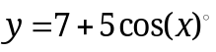
12
for 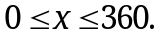

The two graphs intersect at T, which
5
has coordinates 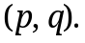
T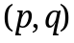

x
0
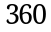

(a) Find the exact value of 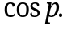 6
(b) Determine the value of p. 2

End of Question Paper

