H

Mathematics Time allowed
Higher 1 hour 30 minutes
Paper 1
Practice Paper B
NATIONAL
QUALIFICATIONS

Read carefully

Calculators may NOT be used in this paper.
Section A – Questions 1 – 20 (40 marks)
Instructions for completion of Section A are given on page two.
For this section of the examination you must use an HB pencil.

Section B (30 marks).
- Full credit will be given only where the solution contains appropriate working.
- Answers obtained by readings from scale drawings will not receive any credit.

© Mathematics Matters 2007
Read Carefully
1 Check that the answer sheet provided is for Mathematics Higher (Section A).
2 For this section of the examination you must use an HB pencil and, where necessary, an eraser.
3 Check that the answer sheet you have been given has your name, date of birth, SCN (Scottish Candidate Number) and Centre Name printed on it.
4 If any of this information is wrong, tell the invigilator immediately.
5 If this information is correct, print your name and seat number in the boxes provided.
6 The answer to each question is either A, B, C or D. Decide what your answer is, then, using your pencil, put a horizontal line in the space provided (see sample question below.)
7 There is only one correct answer to each question.
8 Rough working should not be done on the answer sheet.
9 At the end of the exam, put the answer sheet for Section A inside the front cover of your answer book.

Sample Question
A curve has equation 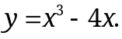
What is the gradient at the point where 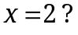
A 8
B 1
C 0
D 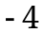
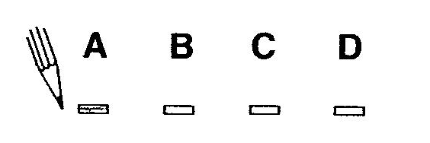
The correct answer is A – 8. The answer A has been clearly marked in pencil with a horizontal line (see below).

Changing an answer
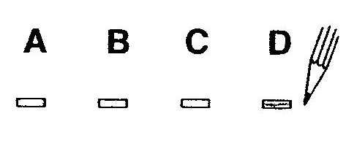
If you decide to change your answer, carefully erase your first answer and using your pencil, fill in the answer you want. The answer below has been changed to D.
FORMULAE LIST

Circle:
The equation 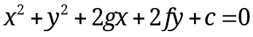 represents a circle centre 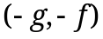 and radius 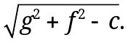
The equation 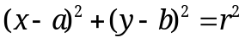 represents a circle centre 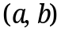 and radius r.

Scalar Product : 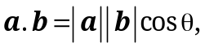 where is the angle between a and b.
or 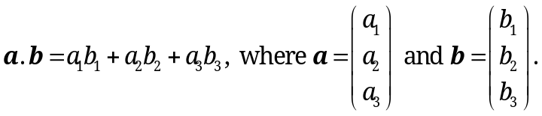

Trigonometric formulae: 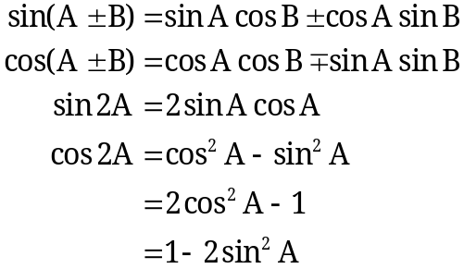

Table of standard derivatives :
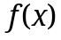 | 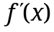
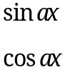 | 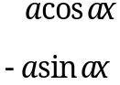

Table of standard integrals :
 | 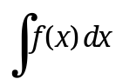
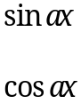 | 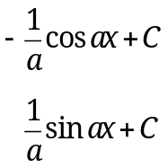

SECTION A
ALL questions should be attempted.

1. Given that 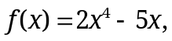 find 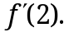
A 6
B 22
C 42
D 59

2. Find 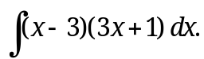
A 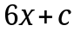
B 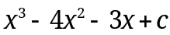
C 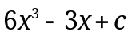
D 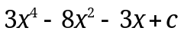

3. P and Q have coordinates 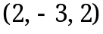 and 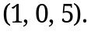
What is the distance between P and Q?
A 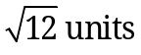
B 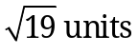
C 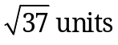
D 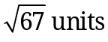

4. If 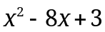 is expressed in the form 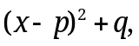 what is the value of q?
A 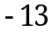
B 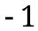
C 3
D 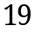

5. Here are two statements about the equation 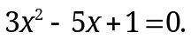
(1) The roots are equal.
(2) The roots are rational.
Which of the following is true?
A Neither statement is correct.
B Only statement (1) is correct.
C Only statement (2) is correct.
D Both statements are correct.

6. Find all the values of x in the interval 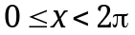 for which 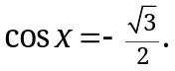
A 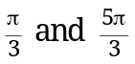
B 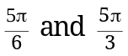
C 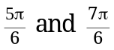
D 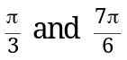

7. S is the point with coordinates 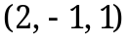, T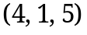 and U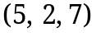.
Find the ratio in which T divides SU.
A 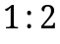
B 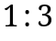
C 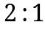
D 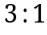

8. Given that 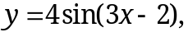 find 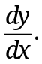
A 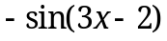
B 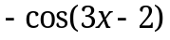
C 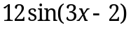
D 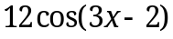

9. The angle between the line shown in
y
the diagram and the x-axis is 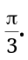
y
What is the gradient of the line?
x
0
A 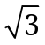
B 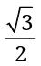
C 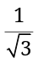
D

10. Given that 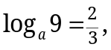 what is the value of a?
A 6
B 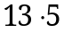
C 27
D 81

11. What is the maximum value of 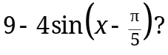
A 1
B 5
C 9
D 13

12. Find 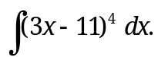
A 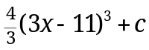
B 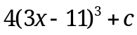
C 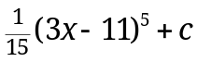
D 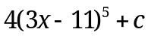

y
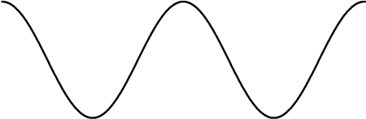
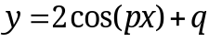13. The graph shown in the diagram
5
has equation of the form 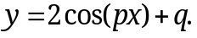
What are the values of p and q?
 | p | q
A |  | 3
B
C
D

1

x
0

14. Given that 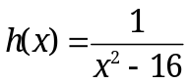, what is the largest possible domain for 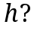
A , the set of real numbers.
B 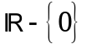
C 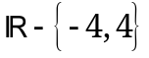
D 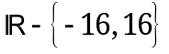

15. Vector has components 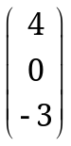. u is a unit vector such that 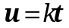, where 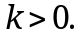
Find the value of k.
A 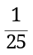
B
C
D

16. The diagram shows the graph of 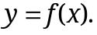
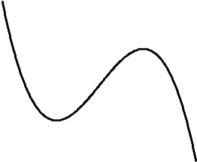
x
0
2
y

Which diagram below shows the graph of 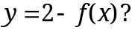
y
2
x
0
A

y
B

2

x
0

y
C

x
0
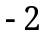

y
D
x
0
17. The equation of the parabola shown
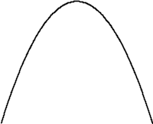
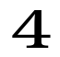
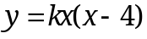
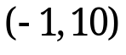

is of the form 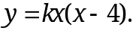
y
x
0
What is the value of k?
A
B
C 1
D 2

18. Simplify 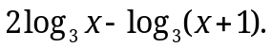
A 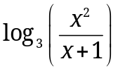
B 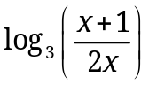
C 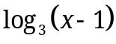
D 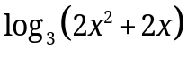

19. What is the solution to 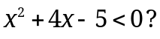
A 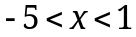
B 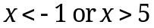
C 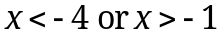
D 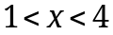

20. If 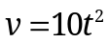 and the rate of change of v with respect to t at 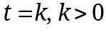 is 160, find
the value of k.
A 0
B 4
C 8
D 16

End of Section A
SECTION B
ALL questions should be attempted.
Marks
21. A circle with equation 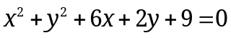 has centre 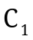.
y
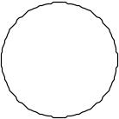
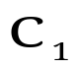
x
0

(a) Write down the coordinates of the centre and find the length of the
radius of this circle. 2
A second circle with equation 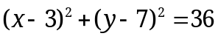 has centre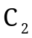.
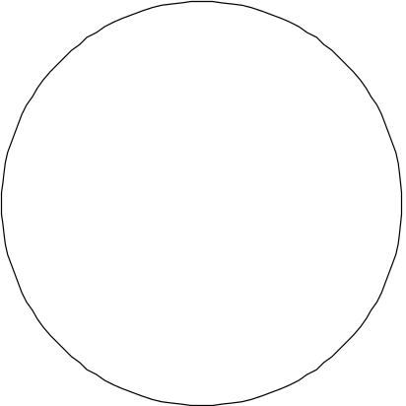
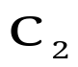
x
0
y

(b) (i) Find the distance between the centres and .
(ii) Hence find the minimum distance between the circumferences of
the two circles. 4

Marks
22. A is the point with coordinates
(a) Express 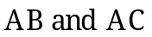 in component form. 2
(b) Find the size of angle BAC. 3

23. Solve 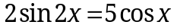 for . 5

24. The diagram shows part of the quartic with equation 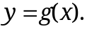
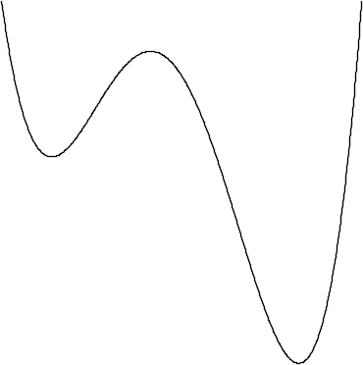
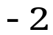
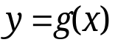
There are stationary points at 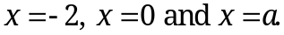
y
x
a
0

On separate diagrams sketch the graph of
(a) 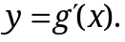 3
(b) 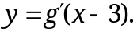 2

25. Find the values of x for which the function 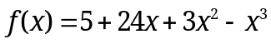 is decreasing. 5

26. P is the point with coordinates 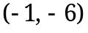 and Q is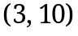.
Find the locus of points which are equidistant from both P and Q. 4

End of question paper

