Maths Primary Control Card File

This is a guide on how to use to using Maths_Primary_Control_Cards.xls file contained within this pack. You require Full Excel Spreadsheet to use file properly.
The idea behind the file is as follows: (Numeracy Map)
The pupils are given a control card with a collection of numberS on it. They need to find the letter associated with these numbers. Once they have found the letters they need to unscramble them to find a mathematical word e.g. DECIMALS & find the total of the numbers on the control card.
- On a piece of paper or electronic file
Write down as many word / words that you want the pupils to work out e.g. Decimals, triangle .... This bank of words doesn’t mean that every child has to complete every course on a particular day. The more words you create the more variety / options you will create for your students.
IMPORTANT : Keep a note of the words you make up. This will be your master answer sheet.
- Open the file and maximise the screen.
- Click on the first tab “O_Maths_Design”
- Scramble the letters up and then entry them into the spreadsheet.
e.g. cedmlias
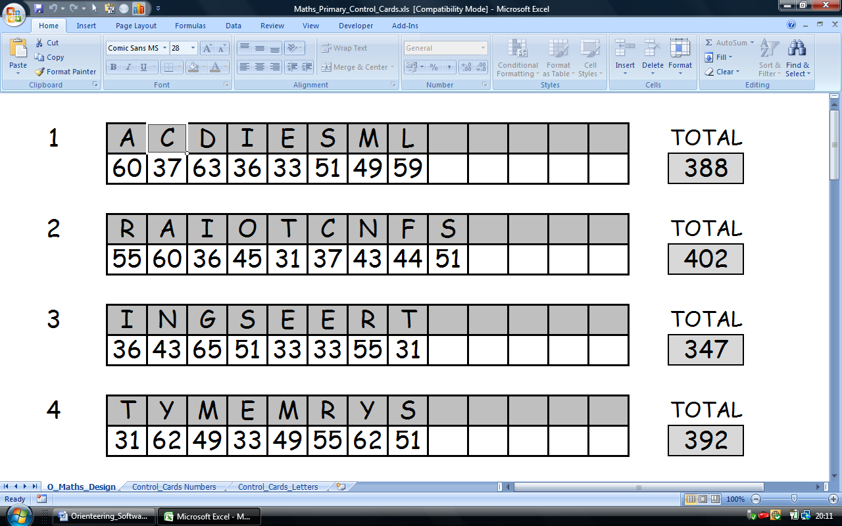

Note the Totals of each control card and entry it into your master sheet.

- Once all the words have been entered into the spreadsheet click on the tab marked “Control_Cards Numbers”

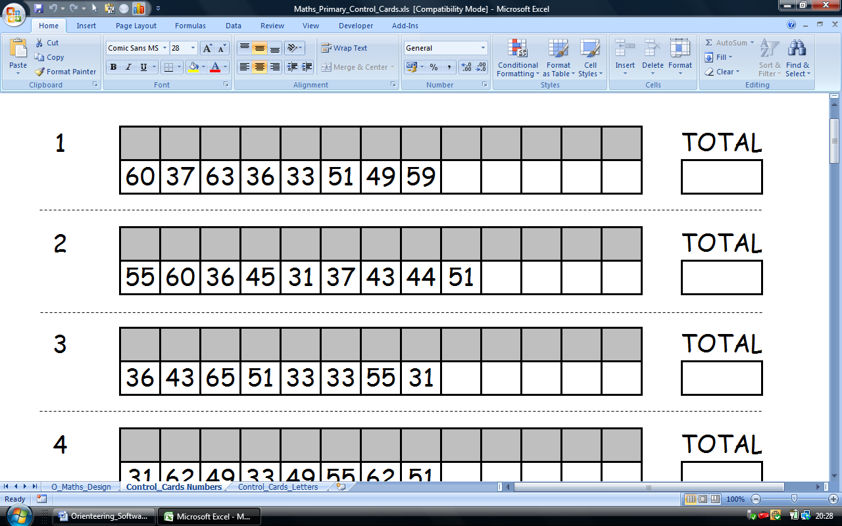

- You now have X different courses to use.

Print out the sheets on card & cut up all the control cards along the dotted line.
You should make several copies of each course possibly using different colours.

- Courses are now ready to be attempted by Pupils using the “Numeracy Map”, a pencil & their Control Card. Always ask students to write their name & date on the back of Control Cards being used.

